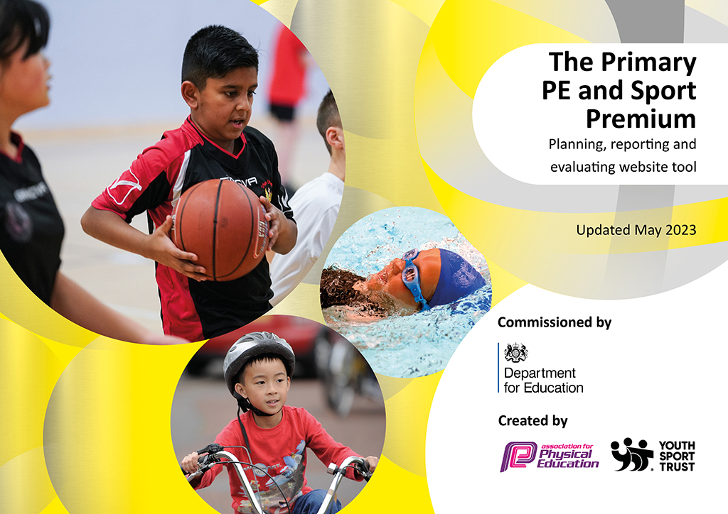
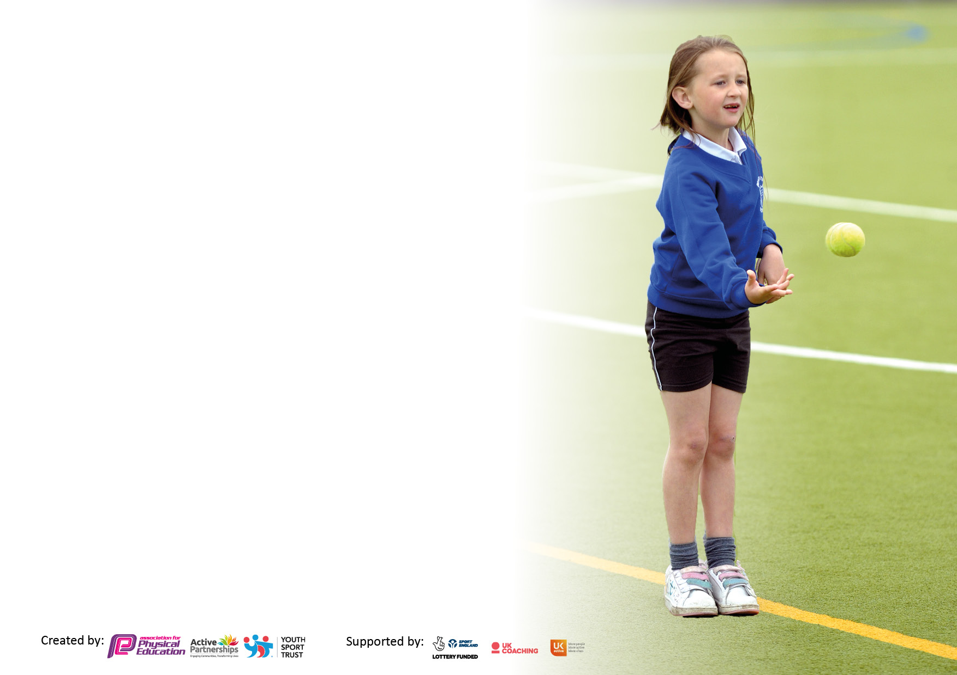

It is important that your grant is used effectively and based on school need. The Education Inspection Framework makes clear there will be a focus on ‘whether leaders and those responsible for governors all understand their respective roles and perform these in a way that enhances the effectiveness of the school’.

Under the Quality of Education Ofsted inspectors consider:
Intent - Curriculum design, coverage and appropriateness
Implementation - Curriculum delivery, Teaching (pedagogy) and Assessment
Impact - Attainment and progress

To assist schools with common transferable language this template has been developed to utilise the same three headings which should make your plans easily transferable between working documents.

Schools must use the funding to make additional and sustainable improvements to the quality of Physical Education, School Sport and Physical Activity (PESSPA) they offer. This means that you should use the Primary PE and sport premium to:

- Develop or add to the PESSPA activities that your school already offer
- Build capacity and capability within the school to ensure that improvements made now will benefit pupils joining the school in future years
- The Primary PE and sport premium should not be used to fund capital spend projects; the school’s budget should fund these.

Please visit gov.uk for the revised DfE guidance including the5keyindicatorsacrosswhichschoolsshoulddemonstrate an improvement. This document will helpyoutoreviewyourprovisionandtoreportyourspend.DfEencouragesschools to use this template as an effective way of meeting the reporting requirements of the Primary PE and Sport Premium.

We recommend you start by reflecting on the impact of current provision and reviewing the previous spend.

Schools are required to publish details of how they spend this funding, including any under-spend from 2021/2022, as well as on the impact it has on pupils’ PE and sport participation and attainment. The funding should be spent by 31st July but the DfE has stated that there will be no clawback of any unspent money so this can be carried forward into 2023/24.

We recommend regularly updating the table and publishing it on your website throughout the year. This evidences your ongoing self-evaluation of how you are using the funding to secure maximum, sustainable impact. Final copy must be posted on your website by the end of the academic year and no later than the 31st July 2023. To see an example of how to complete the table please click HERE.

Details with regard to funding
Please complete the table below.

Total amount carried over from 2022/23 | £0
Total amount allocated for 2023/24 | £16,424
How much (if any) do you intend to carry over from this total fund into 2023/24? | £0
Total amount allocated for 2023/24 | £16,424
Total amount of funding for 2023/24. Ideally should be spent and reported on by 31st July 2024. | £16,424
Swimming Data
Please report on your Swimming Data below.

Meeting national curriculum requirements for swimming and water safety.

N.B. Complete this section to your best ability. For example you might have practised safe self-rescue techniques on dry land which you can then transfer to the pool when school swimming restarts.
Due to exceptional circumstances priority should be given to ensuring that pupils can perform safe self rescue even if they do not fully meet the first two requirements of the NC programme of study
What percentage of your current Year 6 cohort swim competently, confidently and proficiently over a distance of at least 25 metres?  N.B. Even though your pupils may swim in another year please report on their attainment on leaving primary school at the end of the summer term 2023.  Please see note above | %
What percentage of your current Year 6 cohort use a range of strokes effectively [for example, front crawl, backstroke and breaststroke]?  Please see note above | %
What percentage of your current Year 6 cohort perform safe self-rescue in different water-based situations? | %
Schools can choose to use the Primary PE and sport premium to provide additional provision for swimming but this must be for activity over and above the national curriculum requirements. Have you used it in this way? | Yes/No

Action Plan and Budget Tracking
Capture your intended annual spend against the 5 key indicators. Clarify the success criteria and evidence of impact that you intend to measure to evaluate for pupils today and for the future.

Academic Year: 2023/24 | Total fund allocated: | Date Updated:
Key indicator 1: The engagement of all pupils in regular physical activity – Chief Medical Officers guidelines recommend that primary school pupils undertake at least 30 minutes of physical activity a day in school |  |  |  | Percentage of total allocation:
 |  |  |  | %
Intent | Implementation |  | Impact
Your school focus should be clear what you want the pupils to know and be able to do and about what they need to learn and to  consolidate through practice: | Make sure your actions to achieve are linked to your intentions: | Funding allocated: | Evidence of impact: what do pupils now know and what can they now do? What has changed?: | Sustainability and suggested next steps:
Intended Impact on Pupils;  All pupils will be active on average 60 minutes a day, 5 days a week.  Pupils have 15mins physical activity at the start of the school day.  Playtimes are as active as possible for all pupils.  Engage a wider range of pupils in after school clubs. | 15 minutes of daily activity at the start of each school day.  Participation of all pupils in; Whole school Walk each term and Camp Night in the summer term.  Deliver Leadership Training activities from Complete PE to Year 5,6 with the aim of developing playground leaders.  Use the Virtual School Games to provide a focus for playtime activities.  Use student teacher to introduce a lunchtime orienteering club.  Explore ‘Cross Curricular Orienteering’ resources.  Ensure a variety of after school clubs to engage a range of pupils; football, Forest School, table tennis.  Signpost pupils to community sports clubs. | £
Key indicator 2: The profile of PESSPA being raised across the school as a tool for whole school improvement |  |  |  | Percentage of total allocation:
 |  |  |  | %
Intent | Implementation |  | Impact
Your school focus should be clear what you want the pupils to know and be able to do and about what they need to learn and to  consolidate through practice: | Make sure your actions to achieve are linked to your intentions: | Funding allocated: | Evidence of impact: what do pupils now know and what can they now do? What has changed?: | Sustainability and suggested next steps:
Intended Impact on Pupils;  Develop personal, social, communication, team and leadership skills through engagement in PE and school sport. | PE lead to introduce staff to ‘Active Brain Breaks’ (from Complete PE) and include in the KS1 daily routine.  Develop Sports Leaders from pupils in Class 3; Sports Captains for competitions, Sports Day Leaders, involve School Council in delivering workshops and theme days.  PE lead to introduce staff to the range of activity cards within Complete PE scheme which focus on the development of PSE skills.  Celebrate any involvement/achievement in sports and physical activity (in and out of school) during school assemblies.  PE lead to ensure that photos from sports competitions and school PE activities are posted on Facebook and displayed on the School Sports Notice Board. | £

Key indicator 3: Increased confidence, knowledge and skills of all staff in teaching PE and sport |  |  |  | Percentage of total allocation:
 |  |  |  | %
Intent | Implementation |  | Impact
Your school focus should be clear about what | Make sure your actions to | Funding | Evidence of impact: what do | Sustainability and suggested
you want the pupils to know and be able to do | achieve are linked to your | allocated: | pupils now know and what | next steps:
and about what they need to learn and consolidate through practice. | intentions: |  | can they now do? What has changed?
Intended Impact on Pupils:  All pupils participate in two hours of high quality PE, delivered by staff, who are confident in a range of physical activities/sports. | PE lead to develop a MTP in conjunction with the staff who deliver PE lessons in the school and through staff discussion, identify any training/CPD needs.  PE lead to maintain the subscription to the PE scheme ‘Complete PE’ to ensure that ambitious and progressive planning is accessed by staff. PE lead to keep up to date with online training modules delivered by the scheme for new units or long term planning.  Support teaching of PE lessons with specialist coaches to deliver some aspects of the PE curriculum.  PE lead to ensure that this delivery is high quality and ambitious in its outcomes for pupils. | £
Key indicator 4: Broader experience of a range of sports and activities offered to all pupils |  |  |  | Percentage of total allocation:
Intent | Implementation |  | Impact
 | Make sure your actions to | Funding | Evidence of impact: what do | Sustainability and suggested
 | achieve are linked to your | allocated: | pupils now know and what | next steps:
 | intentions: |  | can they now do? What has
 |  |  | changed?:
Intended Impact on Pupils;  Offer a broad range of sports and physical activity to all pupils.  PE and school sport offer is within the school curriculum and through after school clubs/workshops and experience days.  Engage pupils who do not take up additional physical activities outside of the school day. | PE lead to devise a LTP which includes a range of units of work, across Games, Striking, Net & wall, Gym, Dance, OAA & swimming.  Continue with a games based lesson approach, so that lessons are active for all participants and skills are transferable across the different sports.  PE lead to ensure that each half term includes at least one physical activity based, after school club.  Develop connections with the community table tennis club, for curriculum delivery and an after school club.  Support the school curriculum with specialist coach delivery, to allow a range of units to be delivered.  PB to organise workshops or experience days to introduce new sports/physical activity to the curriculum; climbing. cycling | £

Key indicator 5: Increased participation in competitive sport |  |  |  | Percentage of total allocation:
 |  |  |  | %
Intent | Implementation |  | Impact
Your school focus should be clear about what | Make sure your actions to | Funding | Evidence of impact: what do | Sustainability and suggested
you want the pupils to know and be able to do | achieve are linked to your | allocated: | pupils now know and what | next steps:
and about what they need to learn and consolidate through practice. | intentions: |  | can they now do? What has
 |  |  | changed?:
Intended outcome; Pupils will participate in a range of competitive opportunities.  All pupils will participate in at least one inter school festival or competition.  Ensure that in class competition or point scoring activities are a regular feature within a unit of work. | KS2 pupils to attend as many inter school competitions as possible; fell running, cross country, netball, cricket, tri-golf etc.  KS1 pupils to take part in inter school festivals; cricket, tri-golf etc.  PE lead to organise inter school matches with other local schools; cross country, football, netball and cricket.  Each KS2 unit of work will include an inter class competition as the culmination of the lessons.  KS1 lessons will include some aspect of point scoring games; possibly within teams across the class. | £

Signed off by
Head Teacher:
Date:
Subject Leader:
Date:
Governor:
Date:

