

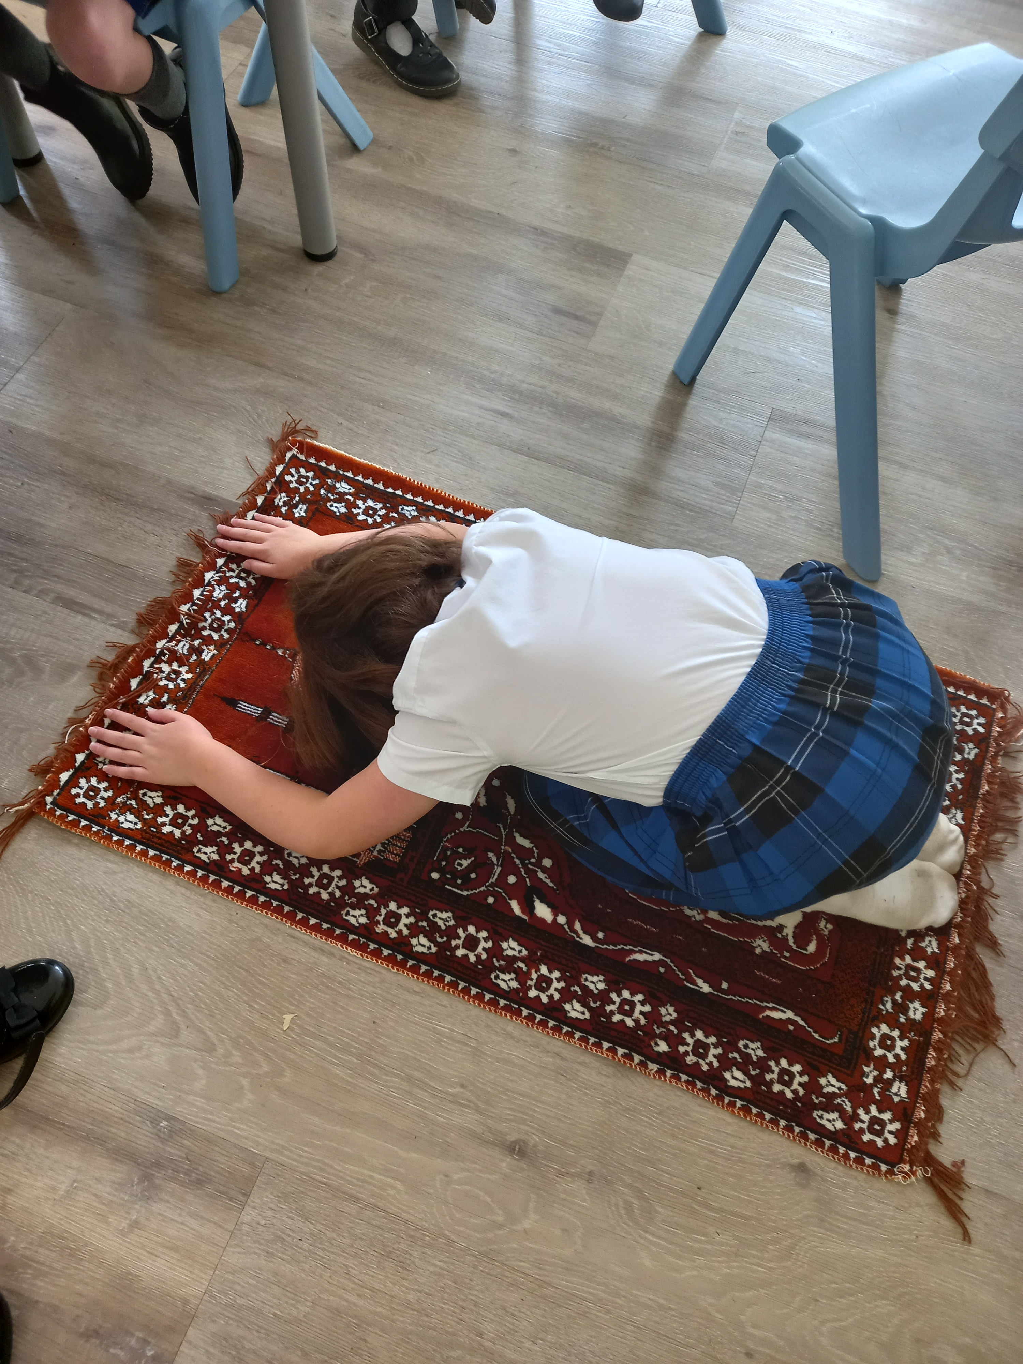

Religious Education Progression Document

| R.E. Progression of Substantive knowledge Map (What we learn) | | | | |
| --- | --- | --- | --- | --- |
|  | EYFS | Key Stage 1 | Lower Key Stage 2 | Upper Key Stage 2 |
| **Beliefs** | *By the end of EYFS, children will be taught to:*   * Recognise that people have different beliefs and celebrate special times. | *By the end of Year 2, children will be taught to:*  ● To know that some people believe God performed miracles in the past.  ● To know that some people believe there are people who are chosen for a special purpose by God.  ● To know that a prophet is someone who talks about God’s plan or will.  ● To know that a saviour is someone who is sent to save a group of people.  ● To know that some people believe that God has made a promise between himself and his people.  ● To know that prayer means communicating with God. | *By the end of Year 4, children will be taught to:*   * To know that religious and non-religious worldviews change over time for individuals and groups. * To know that people from different religions believe some of the same things. * To know that organised and personal religious beliefs change and develop over time. * To know that there are historical links and connections between religions. * To know that sacrifice means giving up something valued for the sake of something else. * To know that holy means divine, sacred or connected to God.      * To know that there is evidence that Jesus was a real person and that people have different beliefs about his significance | *By the end of Year 6, children will be taught to:*  ● To know the meaning of omnipotent (all powerful), omniscient (all knowing) and omnipresent (everywhere at all times).  ● To know some of the ways that culture, history, geography and tradition influence people’s worldviews.  ● To know that some people believe leaders are anointed (chosen by God).  ● To know that people from the same organised worldview often hold the same key beliefs but may interpret and express them differently  . ● To know that free will means humans are able to make their own choices and determine their own fate.  ● To know that beliefs about the nature of God impact people’s ideas about and responses to suffering. |

| R.E. Progression of Substantive knowledge Map | | | | | | | | |
| --- | --- | --- | --- | --- | --- | --- | --- | --- |
|  | | EYFS | Key Stage 1 | | Lower Key Stage 2 | | Upper Key Stage 2 | |
| **Practices** | | *By the end of EYFS, children will be taught to:*   * Understand that some places are special to members of the community * Know some similarities and differences religions and comunities | *By the end of Year 2, children will be taught :*   * To know there are some festivals which are celebrated by religious and non-religious people * To know festivals usually celebrate a special or miraculous event from the past. * To know there are some objects that are special to followers of religious traditions. * To know that one reason religious followers worship is to show gratitude, say ‘thank you’, to god. * To know that people pray in different ways in different places * To know that some people talk to god in different ways and for different reasons | | *By the end of Year 4, children will be taught :*   * To know that the way scriptures are treated and used reflects beliefs about their meaning and origin. * To know that rituals and practices can be based on religious and cultural roots and that often these are interconnected. * To know that the ways scriptures are read and used changes over time. * To know that people with similar worldviews may practice in different ways due to historical events. * To know that practices change over time. | | * *By the end of Year 6, children will be taught :* * To know that some people may use religious practises (e.g prayer, worship,) to help them in times of suffering. * To know that a pilgrimage is a journey to a place of religious significance. * To know that pilgrimages are an important part of some people’s life. * To know that pilgrimage helps some people to feel close to God. * To know that visiting a place of personal, religious, cultural or historical significance can have a special meaning for many people. * To know that there are many reasons for some people taking part in religious practices including belief, culture and tradition. * To know some of the ways practices are influenced by culture, tradition, geography and history. | |
| R.E. Progression of Substantive knowledge Map | | | | | | | | |
|  | EYFS | | | Key Stage 1 | | Lower Key Stage 2 | | Upper Key Stage 2 |
| **Wisdom and morality** | *By the end of EYFS, children will be taught to:*   * See themselves as valuable individuals * Name and describe people who are familiar to them * Talk about the lives of people around them and their roles in society. * Show understanding of their own and others’ needs. | | | *By the end of Year 2, children will be taught :*   * To know that books and stories can have different meaning to different people. * To know that religious stories can help us to understand religious beliefs. * To know that stories from long ago can be applied to modern life. * To know that wisdom means thinking sensibly and taking into account knowledge and experience. * To know that values are what people see as important in life. * To know that prophets and gurus are considered to share god’s wisdom and guidance have had it revealed to them by God. * To know that religions have forms of guidance or rules (commandments) and believers will follow these in different ways | | *By the end of Year 4, children will be taught :*   * To know that stories and scriptures give insights about how to live. * To know that religious texts contain different types of writings. * To know why the bible has a significant role in public life in many countries, including the UK. * To know that religious scriptures come from a range of sources and origins. * To know that religious scriptures are written in different languages and this can affect interpretation. | | *By the end of Year 6, children will be taught :*   * To know that within and between religious and non-religious groups teaching about challenging issues can be contradictory and controversial. * To know that writings from long ago can give people insight into modern day issues. * To know that some people use stories about how others became close to God to guide them in achieving the same aim. * To know that cultural, historical and geographical context can affect how scripture is interpreted. * To know that people disagree on whether ancient writings are still relevant to modern life. |
| R.E. Progression of Substantive knowledge Map | | | | | | | | |
|  | | EYFS | Key Stage 1 | | Lower Key Stage 2 | | Upper Key Stage 2 | |
| **Community and belonging** | | *By the end of EYFS, children will be taught to:*   * See themselves as valuable individuals * Name and describe people who are familiar to them * Talk about the lives of people around them and their roles in society | *By the end of Year 2, children will be taught:*   * To know that many festivals are often celebrated as a community. * To know that some people find praying or worshiping as part of a community helpful. * To know that members of the same community may have similar or different ways of life. To know that many religious groups have special buildings which may have features linked to beliefs and practices. * To know that offerings used to express gratitude may be used to help a person’s local or national community. * To know that within a community people have different values, ideas and beliefs | | *By the end of Year 4, children will be taught :*   * To know that being part of a community with similar beliefs is important to some people. * To know that the history of religion affects how people see their own and others’ communities. * To know that the language used during worship and prayer is important for some people when connecting with their community. * To know that for some people outward expressions of belief are important for a sense of belonging. * To know that disagreement and change happens in communities. | | *By the end of Year 6, children will be taught :*   * To know that people respond in different ways then they see people in their community suffering. * To know that shared challenge can bring people closer together. * To know experiencing a pilgrimage together can help some people feel a sense of community and belonging. * To know that some people feel significant connection to a building or place. * To know that, for some, the people in a particular space are more important than the place itself. * To know that shared practices can be important to give some people a feeling of belonging. * To know that some practices might demonstrate belonging to a particular community. | |

R.E. Progression of Disciplinary Knowledge Map (How we know)

|  |  |  |  |  |  |  |  |  |  |  |  |  |
| --- | --- | --- | --- | --- | --- | --- | --- | --- | --- | --- | --- | --- |
|  | **Ways of knowing** | | | **EYFS** | **Year 1** | | **Year 2** | **Year 3** | **Year 4** | | **Year 5** | **Year 6** |
|  | Exploring stories or scriptures | | |  |  | |  |  |  | |  |  |
|  | Looking at artefacts | | |  |  | |  |  |  | |  |  |
|  | Interviewing others | | |  |  | |  |  |  | |  |  |
|  | Using surveys | | |  |  | |  |  |  | |  |  |
|  | Discussion and debate | | |  |  | |  |  |  | |  |  |
|  | Interpreting art | | |  |  | |  |  |  | |  |  |
|  | Listening to music | | |  |  | |  |  |  | |  |  |
|  | Dramatisation, role play and dancing | | |  |  | |  |  |  | |  |  |
|  | Analysing texts | | |  |  | |  |  |  | |  |  |
|  | Experiences | | |  |  | |  |  |  | |  |  |
|  | Looking at news reports | | |  |  | |  |  |  | |  |  |
|  | Looking at photographs and images | | |  |  | |  |  |  | |  |  |
|  | Interpreting historical sources | | |  |  | |  |  |  | |  |  |
|  | Using video and audio footage | | |  |  | |  |  |  | |  |  |
|  | Using first hand accounts | | |  |  | |  |  |  | |  |  |
|  |  | | |  |  | |  |  |  | |  |  |
| R.E. Progression of Personal Knowledge Map | | | | | | | | | | | | |
|  | | EYFS | Key Stage 1 | | | Lower Key Stage 2 | | | | Upper Key Stage 2 | | |
| **Positionality** | | *By the end of EYFS, children will:*  Use art to show their ideas about identity and belonging.  Ask their own questions about the world around them. Discuss their ideas about what is right and wrong | During Key stage 1, children will develop their understanding of things they have seen, heard or experienced. Children will learn how to respectfully challenge and be challenged on their perceptions, based on thoughts and ideas behind common misconceptions.  They will be encouraged to ask questions and be curious, using talk to share how their thoughts and ideas have changed. | | | Depth of coverage will enable pupils to begin to make sense of different religions, viewpoints and worldviews. Pupils will develop a self-awareness and sensitivity towards their own and others’ beliefs and presumptions and how these affect their responses to the concept and contents taught. Positionality: Children will be encouraged to understand and develop a self-awareness of their own relationship to what they are learning. They will learn how to express their own thoughts in different ways, whilst understanding and reflecting on others’ viewpoints, practising tolerance, acceptance and respect. | | | | Children will be encouraged to understand and develop a self-awareness of their own relationship to what they are learning. They will learn how to express their own thoughts in different ways, whilst understanding and reflecting on others’ viewpoints, practising tolerance, acceptance and respect | | |
| R.E. Progression of Personal Knowledge Map | | | | | | | | | | | | |
|  | | EYFS | Key Stage 1 | | | Lower Key Stage 2 | | | | Upper Key Stage 2 | | |
| **Positionality** | | *By the end of EYFS, children will be taught to:*  Use art to show their ideas about identity and belonging. | *By the end of KS1 children will be taught to*   * Ask questions about what puzzles them about religious and non religious stories and texts they have read. * Express creatively their own ideas about the questions: Who am I? Where do I belong? * Understand that others may have different ideas from their own and responding respectfully. * Express their own ideas and opinions, including considering worldviews studied. * Explain how they have expressed their ideas through art. * Ask thoughtful questions relating to their learning. * Explain why they feel something is right or wrong and comparing their ideas to others. | | | *By the end of Year 4 children will be taught to*   * Discuss their own views about belonging, meaning, purpose and truth. * Present different views thoughtfully and creatively, using evidence from learning. * Ask open questions and suggest responses. * Discuss their own and others’ ideas about deciding what is right and wrong. Suggest ideas about the right ways to treat others, including own opinions and ideas from learning. * Think about their own ideas about God in light of their learning, experiences and discussions. | | | | *By the end of Year 6, children will be taught to :*   * Make links and comparisons between their own and others’ views about belonging, meaning, purpose and truth. * Use creativity to present their own and others’ ideas, explaining their choices. Ask and explore questions from different perspectives, including their own. * Discuss ideas about how their own or another person’s worldview influences their responses to ethical issues. * Express ideas about fairness, honesty, love, forgiveness, truth and peace. * Engage in times of thoughtfulness and reflection and making links between own and others’ experiences. * Express their own thoughts about the existence and nature of God. | | |