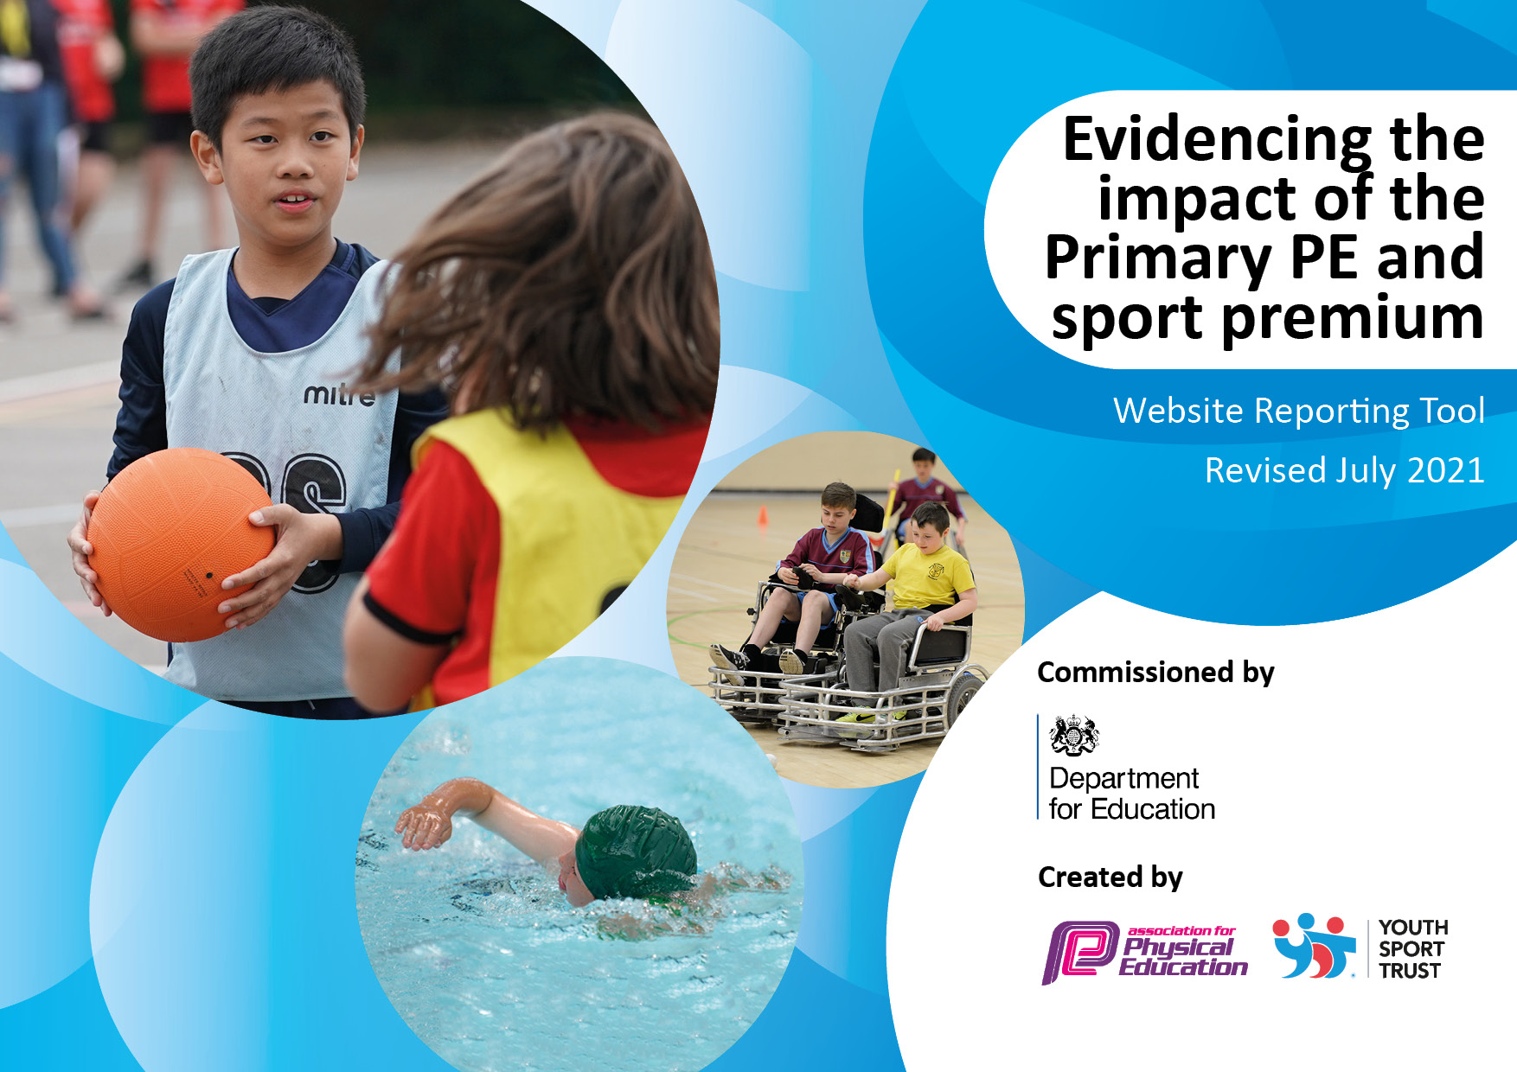
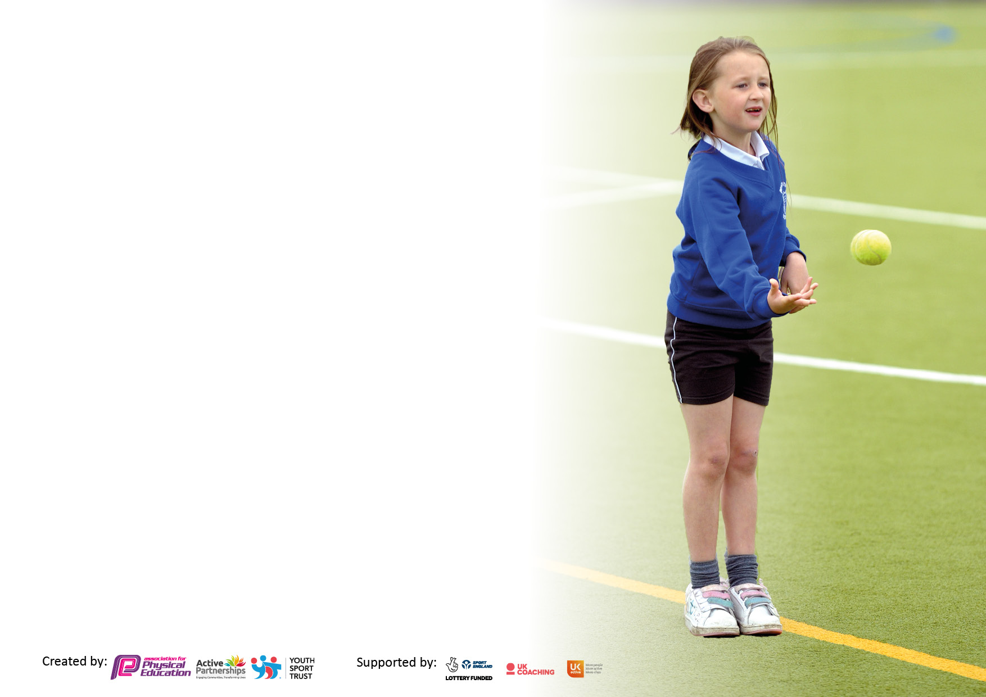

It is important that your grant is used effectively and based on school need. The Education Inspection Framework makes clear there will be a focus on ‘whether leaders and those responsible for governors all understand their respective roles and perform these in a way that enhances the effectiveness of the school’.

Under the Quality of Education Ofsted inspectors consider:
Intent - Curriculum design, coverage and appropriateness
Implementation - Curriculum delivery, Teaching (pedagogy) and Assessment
Impact - Attainment and progress

To assist schools with common transferable language this template has been developed to utilise the same three headings which should make your plans easily transferable between working documents.

Schools must use the funding to make additional and sustainable improvements to the quality of Physical Education, School Sport and Physical Activity (PESSPA) they offer. This means that you should use the Primary PE and sport premium to:

- Develop or add to the PESSPA activities that your school already offer
- Build capacity and capability within the school to ensure that improvements made now will benefit pupils joining the school in future years
- The Primary PE and sport premium should not be used to fund capital spend projects; the school’s budget should fund these.

Pleasevisitgov.ukfortherevisedDfEguidanceincludingthe5keyindicatorsacrosswhichschoolsshoulddemonstrate animprovement.Thisdocumentwillhelpyoutoreviewyourprovisionandtoreportyourspend.DfEencouragesschools to use this template as an effective way of meeting the reporting requirements of the Primary PE and sport premium.

We recommend you start by reflecting on the impact of current provision and reviewing the previous spend.

Schools are required to publish details of how they spend this funding, including any under-spend from 2019/2020, as well as on the impact it has on pupils’ PE and sport participation and attainment. All funding must be spent by 31st July 2022.

We recommend regularly updating the table and publishing it on your website throughout the year. This evidences your ongoing self-evaluation of how you are using the funding to secure maximum, sustainable impact. Final copy must be posted on your website by the end of the academic year and no later than the 31st July 2021. To see an example of how to complete the table please click HERE.

Details with regard to funding
Please complete the table below.

Total amount carried over from 2021/22 | £0
Total amount allocated for 2022/23 | £16,400
How much (if any) do you intend to carry over from this total fund into 2022/23? | £0
Total amount allocated for 2022/23 | £16,400
Total amount of funding for 2022/23. To be spent and reported on by 31st July 2023. | £16,400 (£14,115 spent)
Swimming Data
Please report on your Swimming Data below.

Meeting national curriculum requirements for swimming and water safety.

N.B. Complete this section to your best ability. For example you might have practised safe self-rescue techniques on dry land which you can then transfer to the pool when school swimming restarts.
Due to exceptional circumstances priority should be given to ensuring that pupils can perform safe self-rescue even if they do not fully meet the first two requirements of the NC programme of study
What percentage of your current Year 6 cohort swim competently, confidently and proficiently over a distance of at least 25 metres?  N.B. Even though your pupils may swim in another year please report on their attainment on leaving primary school at the end of the summer term 2023.  Please see note above | 100%
What percentage of your current Year 6 cohort use a range of strokes effectively [for example, front crawl, backstroke and breaststroke]?  Please see note above | 64%
What percentage of your current Year 6 cohort perform safe self-rescue in different water-based situations? | 100%
Schools can choose to use the Primary PE and sport premium to provide additional provision for swimming but this must be for activity over and above the national curriculum requirements. Have you used it in this way? | Yes, 3x open water swimming/water safety sessions.

Action Plan and Budget Tracking
Capture your intended annual spend against the 5 key indicators. Clarify the success criteria and evidence of impact that you intend to measure to evaluate for pupils today and for the future.

Academic Year: 2022/23 | Total fund allocated: | Date Updated: July 2023
Key indicator 1: The engagement of all pupils in regular physical activity – Chief Medical Officers guidelines recommend that primary school pupils undertake at least 30 minutes of physical activity a day in school |  |  |  | Percentage of total allocation:
 |  |  |  | %
Intent | Implementation |  | Impact
All pupils will be active on average 60 minutes a day, 5 days a week.  15 minutes of daily activity at the start of the day.  Develop Young Leaders Skills in upper KS2 pupils. Introduce ‘Sports Captains’ that can work with PE co-ordinator to develop physical activity levels at playtime, lead during the Daily Run/investigate after school club interest/ lead on pupil surveys.  Maintain/ re-invigorate physical activity levels at playtimes/lunchtimes by using the ‘School Games virtual challenges.’  Engage a wider range of pupils in after school clubs.  Keep play times as active as possible for all pupils.  Engage target groups in increased levels of physical activity. | Maintain the daily run, so that all pupils engage in 10 minutes of running/brisk walking 4x a week.  All KS2 pupils will undertake a Young Leaders programme during the academic year.  ‘Sports captains’ roles to be developed.  Develop a varied after-school club programme to encourage maximum participation in physical activity.  Provide a variety of play equipment for playtime use.  Use School Games Virtual Challenges to engage pupils in physical activity at playtimes.  Involve target year groups in a different range of physical activities; climbing/horse riding/ dance/orienteering.  Yoga sessions once a month, led by a yoga instructor. | Funding allocated:£1765 | Evidence of impact: what do pupils now know and what can they now do? What has changed?  Daily run for all pupils continued throughout the academic year, 4x a week. Enhanced by virtual running challenges (Reindeer Run) and school walks.  Impact: All pupils are physically active for the first 15 mins of each day.  An increased number of younger pupils joined after-school clubs this academic year; 20 pupils in running club, 8 pupils in cricket club, 5 pupils in badminton, 12 pupils in athletics  Impact: an additional hour a week of physical activity for those pupils involved in clubs.  Playground equipment updated/replaced and new playground markings installed. All weather KS1 Outdoor play area installed. Pupils continue to enjoy the large climbing equipment, the basketball hoop, football pitch and generally playing on the large grass area.  Impact: Pupil physical activity level is high during play times.  KS1 pupils have their own outdoor play area for extended playtimes.  A target group of year 6 pupils were mentored by a student to provide playtime orienteering activities for younger pupils.  Impact: increased physical activity for them as they set out the course and monitored the pupils taking part. A sustained 20 mins of physical activity for those pupils involved. | Sustainability and suggested next steps:  Maintain attendance in clubs from KS1 pupils. Increase attendance in clubs of KS2 pupils.
Key indicator 2: The profile of PESSPA being raised across the school as a tool for whole school improvement |  |  |  | Percentage of total allocation:
 |  |  |  | %
Intent | Implementation |  | Impact
All pupils’ physical and personal/social achievements will be developed and celebrated.  Develop the whole child through physical activity, PE and School Sport.  Link the focus on children’s personal and social development with the School Development Plan to ensure that its importance is recognised by parents, staff and Governors. | Continue whole school outdoor events; one per term.  Outdoor education opportunities for all pupils at some point in the year to develop team co-operation/leadership and resilience skills.  Outdoor Education residentials for both KS2 classes.  Maintain profile of sports competition and achievement in school;  -sports photo board  -photos and write ups on Facebook page (why we do it, as well as what we did)  -certificates given out in assembly  - celebrate pupils’ sports achievements outside of school.  Show case learning in PE through demonstrations in assemblies or short dance/gymnastic performances for parents.  Develop the role of Sports Captains. | Funding allocated  £2595 | Evidence of impact: what do pupils now know and what can they now do? What has changed?  The whole school took part in a school walk in the autumn term and camp evening in the summer term.  Impact: all pupils engaged in enjoyable outdoor activity which encourages social interaction, communication, responsibility and team building skills.  KS1 took part in an outdoor education day, Yr3,4 had a one night residential at Newlands Adventure Centre and YR5,6 had a two night residential at Coniston YHA.  Impact: all pupils engaged in an enjoyable outdoor activity which encouraged social interaction, communication, responsibility and team building skills.  School sport competition board in school entrance regularly updated. Competitions/ event photos posted on Facebook page. Sports and physical activity achievements (in and out of school) celebrated in assembly.  Impact: Pupils, parents, staff and governors recognise the value placed on PE, physical activity and school sport; pupils by their engagement, parents by their support in attending events, staff by their support with events and the amount of time pupils are allowed to participate, Govs by their attendance at events and their interest during govs meetings.  PE co-ordinator met with the PE Governor twice throughout the year to review PE and sport in the school and then provided feedback to the Governors. PE Governor also attended the Yr3,4 residential.  Impact: The PE Governor has an input into this plan and Governors are informed of how the funds are used. PE Governor is informed and up to date on PE and School Sport at our school. | Sustainability and suggested next steps:

Key indicator 3: Increased confidence, knowledge and skills of all staff in teaching PE and sport |  |  |  | Percentage of total allocation:
 |  |  |  | %
Intent | Implementation |  | Impact
All children participate in two hours a week of high quality PE delivered by confident and competent staff. | Continue with the use of Complete PE to plan and deliver active and engaging PE lessons which develop the whole child.  Staff CPD on the use of the key questions and exemplar videos available in the Complete PE Scheme.  Support curriculum delivery with CDP from courses and specialist coaches where needed/available.  Ensure adequate resources are available for curriculum delivery to ensure maximum participation. | Allocated Funding  £3156,84 | Evidence of impact: what do pupils now know and what can they now do? What has changed?  Complete PE scheme used to support curriculum delivery.  PE co-ordinator has accessed online learning videos and webinars.  Impact: PE delivery is based on high quality planning which correlates with the school’s ethos on the experience of pupils in PE lessons.  Each class has two hours of timetabled PE per week; in KS2 one of these lessons a week is delivered by the PE co-ordinator and the other may be delivered by a swimming teacher or a sports coach.  CPD for KS1 teacher in dance, basic throwing, catching and striking skills. CPD for KS2 teacher in tennis, cricket, netball & dance.  Impact: staff continue to undertake in house CPD which is time efficient and reduces the need to travel for professional development. | Sustainability and suggested next steps:  Continue to develop staff confidence through the use of the Complete PE scheme and sports coaches.
Key indicator 4: Broader experience of a range of sports and activities offered to all pupils |  |  |  | Percentage of total allocation:
Intent | Implementation |  | Impact
Pupils will have access to a broad and balanced PE curriculum, which responds to their interests.  Pupils will have access to a range of after school and lunchtime clubs which reflects their interests and introduces new skills.  Opportunities to engage in festivals and event days will be capitalised upon to extend the range of physical activities that pupils experience. | The Long Term PE Plan will include a range of PE activities which teach children a range of skills and knowledge (non-sport specific at KS1) (Transferable skills across the sport types at KS2)  Pupil surveys will reveal their interests in PE activities and these will be included in the curriculum, where possible.  Pupil surveys will reveal interests in after school/lunchtime club activities and these will be delivered where possible.  Opportunities for involvement in events days/ taster activities and festivals will be taken, where possible. | Funding allocated  £5,645.75 | Evidence of impact: what do pupils now know and what can they now do? What has changed?  Pupils were surveyed before at start of the academic year and their request for basketball lessons was included in the long term plan for the year. The KS2 curriculum plan for the year included a range of invasion games (basketball & netball) dance, gymnastics, cricket, net & wall games (tennis & table tennis) swimming, open water swimming and outdoor/adventurous activities. The KS1 curriculum included ball skills (striking and kicking, throwing and catching) dance, gymnastics and swimming.  Impact: pupils continue to experience a range of sports activities, whilst continuing to build upon previously learnt skills and apply these across a range of sports.  Pupil surveys revealed that upper kS2 were not routinely enjoying PE sessions as they preferred to play the sports, rather than be instructed/practice skills, so PE sessions were adapted to include further games based skills activities. Pupils feedback during lessons, indicated that this was more to their liking.  Impact: Lessons were adapted, pupil engagement and enjoyment improved.  After school clubs have included; running, netball, athletics, cricket and badminton (requested on pupil surveys)  Participation numbers; an after school club has between 5 and 20 pupils attending; depending on the activity and the day of the week (attendance at community dance clubs is high on Tuesday and Thursday)  Impact: All pupils have had the opportunity to become involved in a range of after school clubs and try new activities.  KS2 pupils had a table tennis taster session with a local coach. | Sustainability and suggested next steps;  Follow up on the table tennis taster session by including a block of table tennis in the next year’s curriculum plan.
Additional achievements: |  | £

Key indicator 5: Increased participation in competitive sport |  |  |  | Percentage of total allocation:
 |  |  |  | %
Intent | Implementation |  | Impact
All pupils will take part in several inter- school competition or festivals during the academic year.  All KS2 pupils will engage in class competition within units of work, where applicable. | KS2 pupils will attend local schools’ competitions where possible, in a variety of sports.  KS2 pupils will attend county wide cross country events and county finals if selected.  KS1 pupils will participate in as many local schools’ festivals as possible.  KS1 PE lessons will have aspects of competition where pupils can score points within activities.  KS2 PE units of work will include team competition and point scoring activities. | Funding allocated:  £1957.5 | Evidence of impact: what do pupils now know and what can they now do? What has changed?  Year 5,6 pupils took part in a local schools’ netball competition. All KS2 pupils took part in two local schools’ cross country competitions and the Tri-golf county finals. More than half of the pupils in KS2 took part in The South Lakes District cross country championships and four pupils qualified for the county finals. Year 3,4 took part in a tri-golf festival (and qualified for the county final) and a kwik cricket festival. Year 5,6 were entered in the Small Schools Kwik Cricket Festival and the County Finals but both were cancelled due to the weather.  Impact: All pupils in KS2 have competed in at least 3 inter school competitions during this academic year. There were eight inter school competition opportunities taken during the academic year. Pupils experienced competitive competition at different levels; with local schools and schools from across the county.  KS2 PE lessons include a inter class competition at the end of a unit and point scoring games within the lessons. Clubs include point scoring games within the activities.  KS1 & KS2 lessons include a variety of small sided, point scoring activities as this is very much a feature of Complete PE lessons.  Impact: All pupils experience point scoring and competitive activities in a familiar context. | Sustainability and suggested next steps;  Continue to attend as many local schools’ festivals/competitions as possible.  Increase participation of KS1 pupils in festivals.  Participate in competitions with schools in the locality.

Signed off by
Head Teacher: | C. Sharp
Date: | 29.7.23
Subject Leader: | P. Bowen
Date: | 20.7.23
Governor: | C.Brammall
Date: | 29.7.23

