

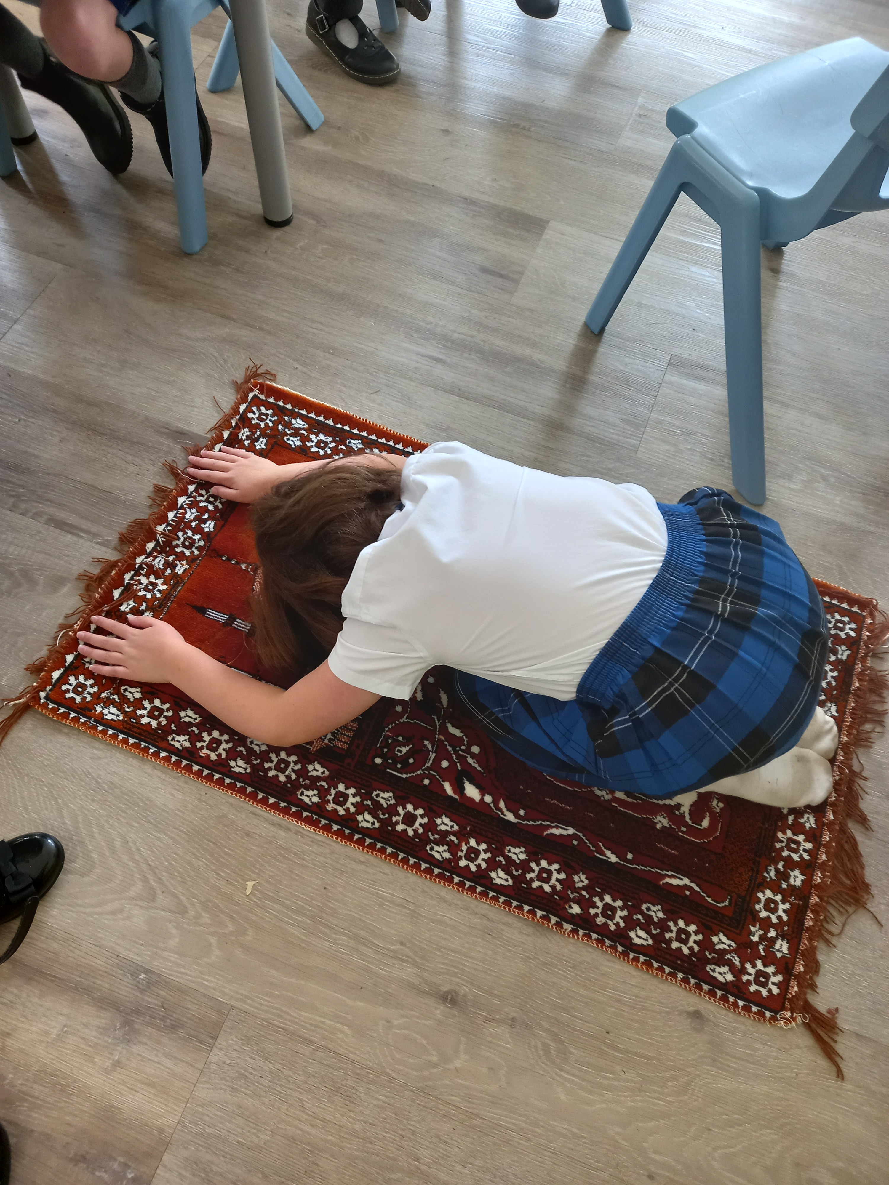

Religious Education Progression Document

| R.E. Progression of Sunstantive knowledge Map | | | | |
| --- | --- | --- | --- | --- |
|  | EYFS | Key Stage 1 | Lower Key Stage 2 | Upper Key Stage 2 |
| **Understand beliefs and teachings** | *By the end of EYFS, children will be taught to:*   * Recognise that people have different beliefs and celebrate special times. | *By the end of Year 2, children will be taught to:*  • Describe some of the teachings of a religion.  • Describe some of the main festivals or celebrations of a religion | *By the end of Year 4, children will be taught to:*  • Present the key teachings and beliefs of a religion.  • Refer to religious figures and holy books to explain answers. | *By the end of Year 6, children will be taught to:*  . • Explain how some teachings and beliefs are shared between religions.  • Explain how religious beliefs shape the lives of individuals and communities. |

| **Understand practices and lifestyles** | *By the end of EYFS, children will be taught to:*   * Understand that some places are special to members of the community * Know some similarities and differences between different religions and communities | *By the end of Year 2, children will be taught to:*  • Recognise, name and describe some religious artefacts, places and practices. | *By the end of Year 4, children will be taught to:*  • Identify religious artefacts and explain how and why they are used.  • Describe religious buildings and explain how they are used.  • Explain some of the religious practices of both clerics and individuals. | *By the end of Year 6, children will be taught to:*  .• Explain the practices and lifestyles involved in belonging to a faith community.  • Compare and contrast the lifestyles of different faith groups and give reasons why some within the same faith may adopt different lifestyles.  • Show an understanding of the role of a spiritual leader. |
| --- | --- | --- | --- | --- |

| R.E. Progression of Substantive Knowledge Map | | | | |
| --- | --- | --- | --- | --- |
|  | EYFS | Key Stage 1 | Lower Key Stage 2 | Upper Key Stage 2 |
| **Understand how beliefs are conveyed** | *By the end of EYFS, children will be taught to:*   * Understand the past through settings, characters and events encountered in books read in class and through story telling | *By the end of Year 2, children will be taught to:*  • Name some religious symbols.  • Explain the meaning of some religious symbols. | *By the end of Year 4, children will be taught to:*   * Identify religious symbolism in literature and the arts. | *By the end of Year 6, children will be taught to:*  • Explain some of the different ways that individuals show their beliefs |

| R.E. Progression of SKILLS Map | | | | |
| --- | --- | --- | --- | --- |
|  | EYFS | Key Stage 1 | Lower Key Stage 2 | Upper Key Stage 2 |
| **Understand values** | *By the end of EYFS, children will be taught to:*   * See themselves as valuable individuals * Name and describe people who are familiar to them * Talk about the lives of people around them and their roles in society. * Show understanding of their own and others’ needs. | *By the end of Year 2, children will be taught to:*  • Identify how they have to make their own choices in life.  • Explain how actions affect others.  • Show an understanding of the term ‘morals’. | *By the end of Year 4, children will be taught to:*  • Explain how beliefs about right and wrong affect people’s behaviour.  • Describe how some of the values held by communities or individuals affect behaviour and actions.  • Discuss and give opinions on stories involving moral dilemmas. | *By the end of Year 6, children will be taught to:*  • Explain why different religious communities or individuals may have a different view of what is right and wrong.  • Show an awareness of morals and right and wrong beyond rules (i.e. wanting to act in a certain way despite rules).  • Express their own values and remain respectful of those with different values. |