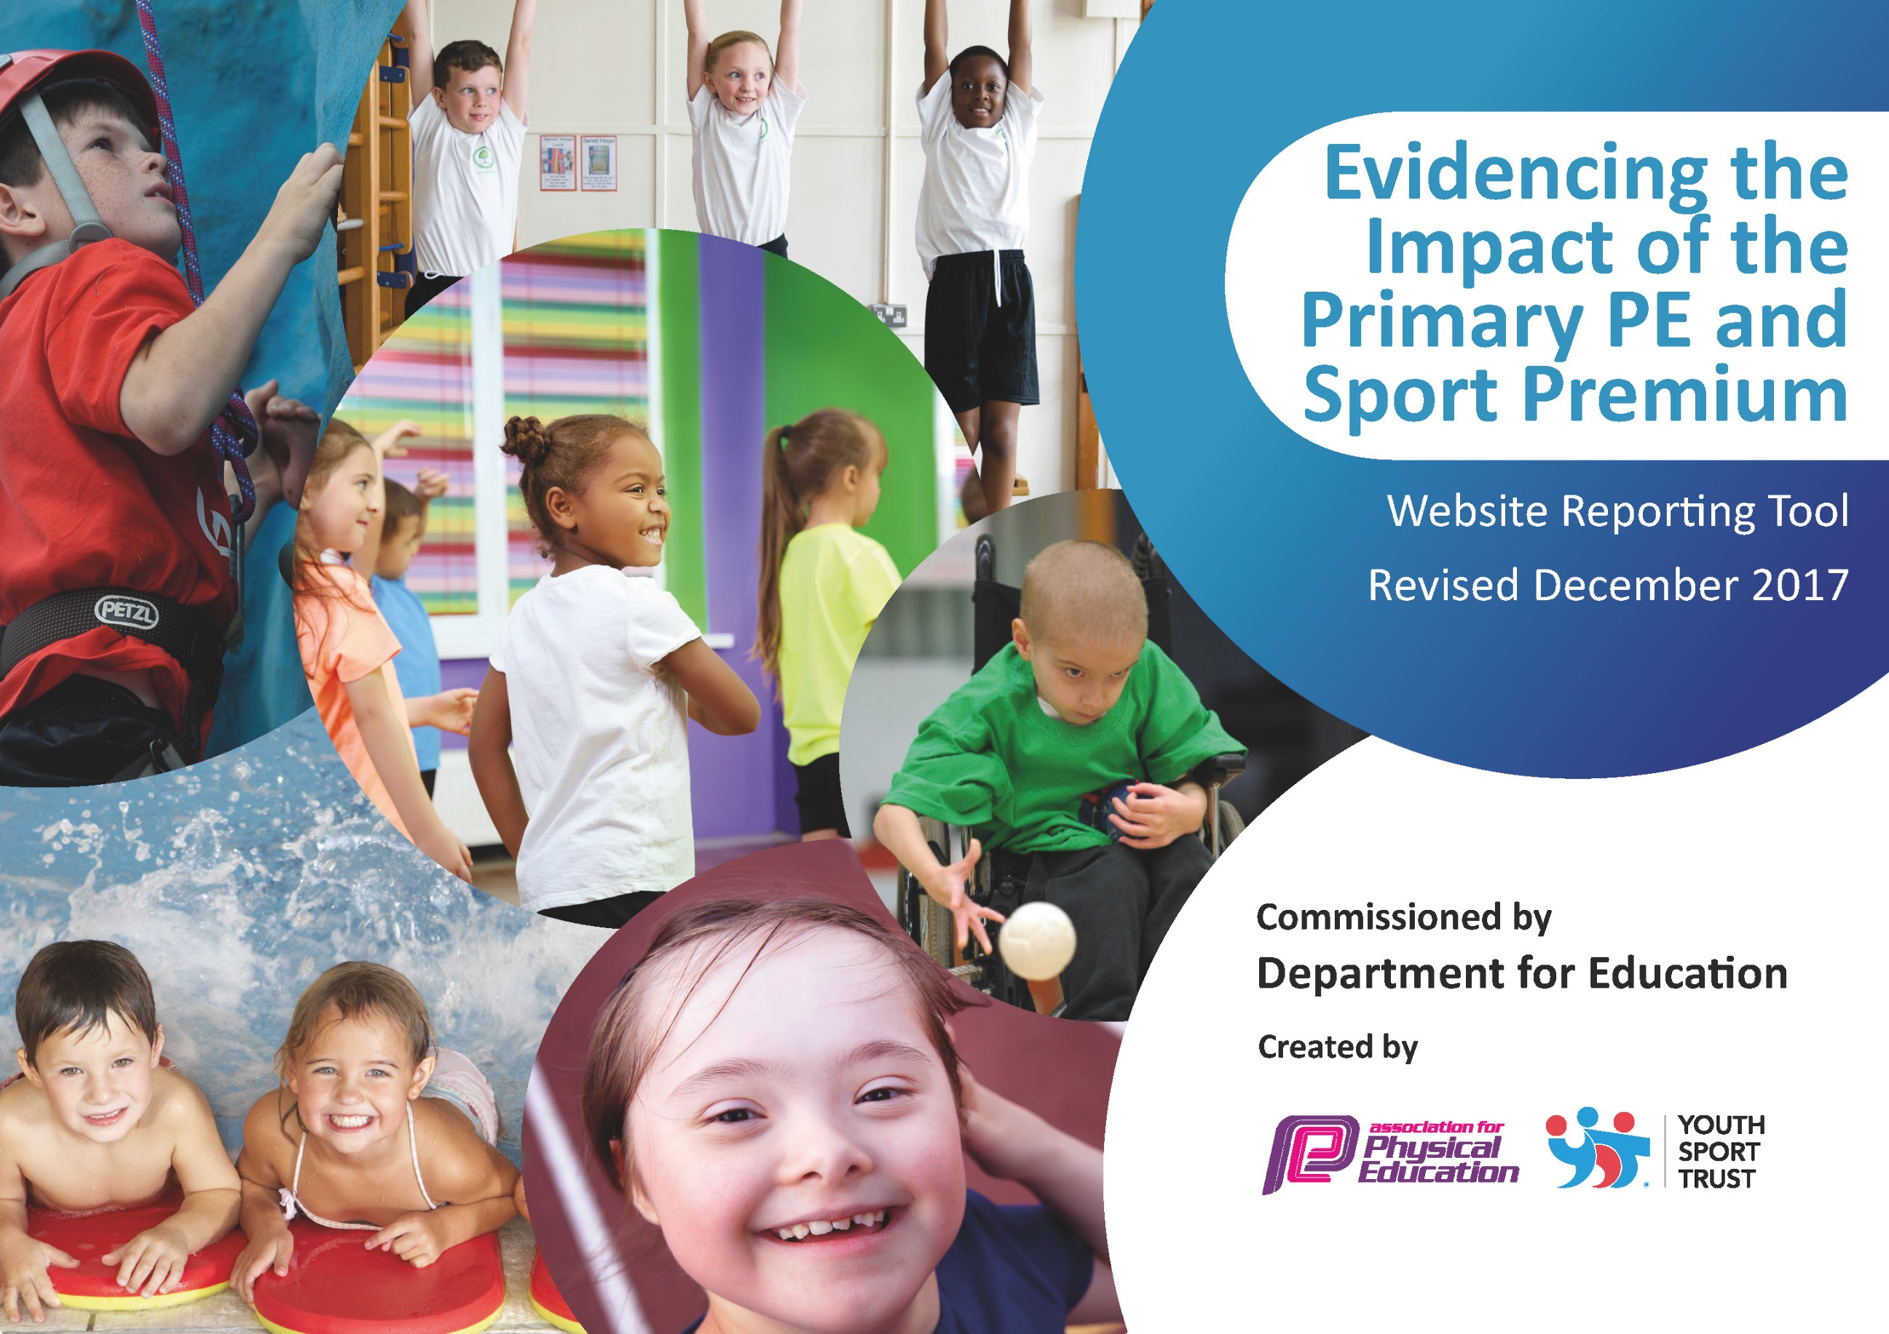

Schools must use the funding to make additional and sustainable improvements to the quality of PE and sport they offer. This means that you should use the Primary PE and Sport Premium to:

- developoraddtothePEandsportactivitiesthatyourschoolalready offers
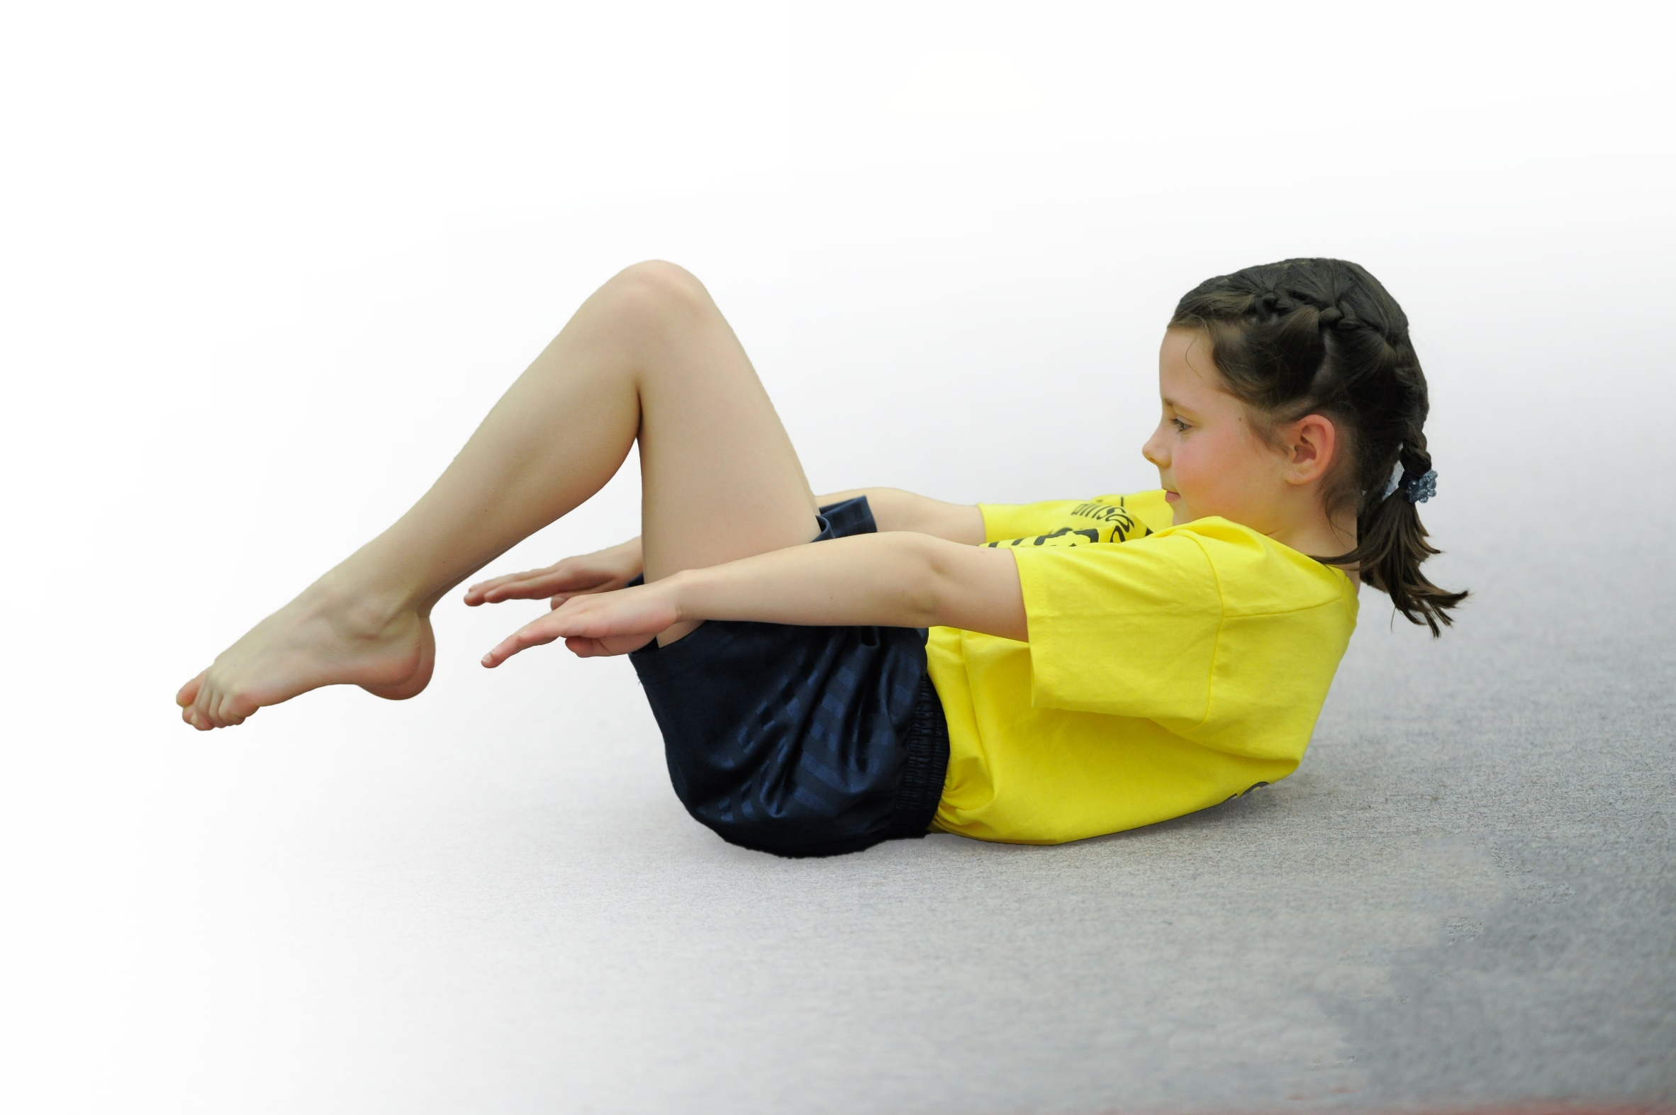
- buildcapacityandcapabilitywithintheschooltoensurethatimprovementsmadenowwillbenefitpupilsjoiningtheschoolinfuture years

Please visit gov.ukfor the revised DfE guidance including the 5 key indicators across which schools should demonstrate an improvement. This document will help you to review your provision and to report your spend. DfE encourages schools to use this template as an effective way of meeting the reporting requirements of the Primary PE and Sport Premium.

We recommend you start by reflecting on the impact of current provision and reviewing the previous spend.
Under the Ofsted Schools Inspection Framework, inspectors will assess how effectively leaders use
the Primary PE and Sport Premium and measure its impact on outcomes for pupils, and how effectively governorshold them to account
for this.

Schools are required to publish detailsof how they spend this funding as well as on the impact it has on pupils’ PE
and sport participation and attainment.
We recommend regularly updating the table and
publishing it on your website as evidence
of your ongoing review into how you are using the money
to secure maximum, sustainable impact. To see an example of how to complete the table please click HERE.
Support for review and reflection - considering the 5 key indicators from DfE, what development needs are a priority for your setting and your students now and why? Use the space below to reflect on previous spend, identify current need and priorities for the future.

Key achievements to date: | Areas for further improvement and baseline evidence of need:
Varied PE curriculum  Inter school competitions and festivals  Opportunity for open water swimming.  Embedded school mile activity twice weekly. | Vary competition opportunities for KS2 to engage all pupils  Develop PE long term plan to incorporate wholistic developments of pupils as well as physical ones. Recognise mental well being benefits of physical activity.  Invesigate and implement a whole school PE scheme which delivers a game based approach to PE lessons.

Meeting national curriculum requirements for swimming and water safety | Please complete all of the below*:
What percentage of your current Year 6 cohort swim competently, confidently and proficiently over a distance of at least 25 metres? | 100%
What percentage of your current Year 6 cohort use a range of strokes effectively [for example, front crawl, backstroke and breaststroke]? | 100%
What percentage of your current Year 6 cohort perform safe self-rescue in different water-based situations? | 100%
SchoolscanchoosetousethePrimaryPEandSportPremiumtoprovideadditionalprovisionforswimming but this must be for activity over and above the national curriculum requirements. Have you used it in this way? | Yes

Action Plan and Budget Tracking
Capture your intended annual spend against the 5 key indicators. Clarify the success criteria and evidence of impact that you intend to measure to evaluate for students today and for the future.

Academic Year: 2020/21 | Total fund allocated: £16,450 | Date Updated: September 2021
Key indicator 1: The engagement of all pupils in regular physical activity – Chief Medical Officer guidelines recommend that primary school children undertake at least 30 minutes of physical activity a day in school |  |  |  | Percentage of total allocation:
 |  |  |  | %
School focus with clarity on intended impact on pupils: | Actions to achieve: | Funding allocated: | Evidence and impact: | Sustainability and suggested next steps:
Maintain ‘Tuesday Trot’ running session to 2x weekly so that all pupils engage in 10 minutes of running/brisk walking twice a week.  Implement the Young Leaders programme for KS2 in the Summer Term.  Replace the playground climbing equipment to ensure active playtimes and allow more children to engage in active play.  Introduce increased activity into playtimes; ‘Well being weeks’ New rota of activities, new equipment and storage.  Offer alternative after-school activity such as climbing wall sessions, to engage a range of pupils in physical activity. | PB ensure that the routine of 2x weekly Trot continues in the new academic year.  Include some running based challenges (Lakeland Lapland Adventures) to maintain engagement and motivation.  PB to deliver The Young Leaders training programme to KS2 in summer term 2021  PB Investigate the options for replacing the climbing equipment.  ‘Well being week’ in autumn term to include a range of new playtime activities.  New rota of playtime activities, new resources and storage equipment.  PB attending active play training session; ‘Boing Kids.’  PB to investigate small group climbing wall sessions for a rotation of groups.  Investigate cycling sessions on school grounds for a rotation of small groups. | £13,242.56  £478.90 | This was maintained during the Autumn term and then increased to 3x weekly after returning from the post- Christmas lockdown. A weekly walk in the local area was also introduced.  Climbing equipment replaced in the summer break.  Playtime equipment updated and selection of activities widened to encourage active playtimes. Rota was introduced to allow pupils to try a selection of activities (cricket, tennis, netball, skipping, multi-skills)  PB attended active play training session. Playground games introduced during PE warm ups and TA facilitated these as playtime activities.  Not done. | These 4x weekly physical activity sessions are to be continued into the next academic year.  Climbing equipment could be used as part of gymnastic sessions to incorporate hanging and swinging activities.  Playtime equipment and rota to continue into next academic year.  Carry this idea forward into 2021/2022
Key indicator 2: The profile of PE and sport being raised across the school as a tool for whole school improvement |  |  |  | Percentage of total allocation:
 |  |  |  | %
School focus with clarity on intended impact on pupils: | Actions to achieve: | Funding allocated: | Evidence and impact: | Sustainability and suggested next steps:
Outdoor education opportunities for all pupils at some point in the year to develop team co-operation/leadership and resilience skills.  Maintain profile of sports competition and achievement in school;  -sports notice board  -photos and write ups on Facebook page  -certificates given out in assembly  Start a sports newsletter each term with photos and reports written by the pupils who have participated.  Ensure that school sport and PE activities are included in the SMSC action plan for 2020/21 | Opportunities for whole school outdoor education day in the spring term and a second activity for each class in the summer term.  PB to update sports notice board/provide photos and write ups for Facebook  Staff to include sports news/certificates in praise assemblies.  PB to initiate pupils to contribute to a termly sports newsletter.  SMSC Plan audited and revised in autumn term 2020 by all staff. | £1,420 | Class 1 and 2 had an afternoon of rafted canoeing in the summer term. Class 3 had 3 sailing afternoons.  The whole school had 3 outdoor days where we walked, picnicked, orienteered and completed outdoor challenges.  Due to Covid restrictions there were no face to face competitions.  Facebook and school website was used to update parents and the community on our daily runs, outdoor days and outdoor education activities.  Physical activity became a fundamental part of our post lockdown activities to ensure that children regained physical fitness and to contribute to their mental wellbeing. | If funding allows, this will be repeated in the summer term of 2021. Plus an outdoor education residential for class 2.  Whole school outdoor days will continue into 2021-22

Key indicator 3: Increased confidence, knowledge and skills of all staff in teaching PE and sport |  |  |  | Percentage of total allocation:
 |  |  |  | %
School focus with clarity on intended  impact on pupils: | Actions to achieve: | Funding  allocated: | Evidence and impact: | Sustainability and suggested  next steps:
Ensure staff have enough support/training/resources to deliver a broad and balanced PE curriculum.  Further dance/gymnastics CPD for RY, working alongside dance/gymnastics teacher.  Net/wall games CPD for SK/PB to develop skills and knowledge for future lessons/after school clubs.  Athletics CPD for RY/PB for future curriculum delivery.  Revise Long Term PE Plan to include an extended range of PE activities and develop a game based approach to PE delivery. | Investigate, trial and implement a whole school PE scheme which equips teachers with a range of activities and opportunities for peer and teacher assessment in PE lessons.  Membership to Youth Sport Trust  Coaching staff booked for CPD/class work in autumn/spring term.  PB to devise new PE Long Term Plan during autumn term.  PB participate in as many PE Network Meetings as is feasible. | £1065.00  £1,030.00  £560.00 | A new PE scheme was bought which includes lesson plans for all PE units, links to Youth Sport Trust activities, guidance for teachers on key questions, next steps and assessment. Also includes a progress tracker if required, though we do have a PE tracker on our school assessment system.  RY worked alongside the dance/gymnastics teacher in the autumn and spring term. RY’s second PE lesson of the week built on and continued with the skills and knowledge that she had observed in the specialist led lesson.  PB has begun a draft of a new PE Long Term Plan which outlines the holistic benefits of PE activities. New PE scheme covers a game based approach to developing and applying skills.  PB attended two online PE Network Meetings. | PE scheme will continue to be used in the next academic year by those staff delivering PE.  PE LTP to continue into the new academic year for completion.
Key indicator 4: Broader experience of a range of sports and activities offered to all pupils |  |  |  | Percentage of total allocation:
 |  |  |  | %
School focus with clarity on intended  impact on pupils: | Actions to achieve: | Funding  allocated: | Evidence and impact: | Sustainability and suggested  next steps:
Continue to offer a range of sports/PE activities within curriculum time and after-school clubs to engage all pupils and develop a range of skills.  Autumn 1 netball curriculum delivery for all KS2 pupils  Swimming lessons offered to all pupils to develop water confidence and swimming skills.  Ensure all pupils in Yr5,6 can swim 25m  Whole school cycling day in Grizedale Forest to develop/challenge cycling skills.  KS1 cycling skills development day.  (practice riding/ develop maneuvering skills/ off road cycling for yr2)  Further develop well-being and holistic development of pupils through different types of physical activity.  Year 5,6 to learn open water swimming skills, including life- saving.  A whole school evening of outdoor environmental activities, including camping out for Yr6.  PE resources kept up to date with enough equipment for whole class participation. | PB to plan a varied PE curriculum map which includes support of specialists where necessary.  PB to review and re-write the Long Term PE plan to highlight the holistic child developments which PE & SS can offer to children.  Use after-school club coaches where available to supplement the clubs that staff can offer.  PB to arrange swimming lessons for all pupils in summer term.  PB to arrange open water swimming sessions for Yr5,6 in summer term.  Plan a date in Spring Term for day of cycling/ picnic lunch/followed by team building activities in forest.  Plan a date in autumn/spring/summer term for KS1 to bring bikes and take part in cycling skills development activities.  Yoga sessions booked for all children in autumn term.  PB to arrange three open water swimming for upper KS2 pupils.  PB to organize the annual Whole School Bushcraft Evening. | Costs included in Sports coaches figure.  £600  £3,631.00  £2,502.50  £390.00  £335.00  £700 | In the terms that we were in school;  The PE curriculum included;  Class 1- ball skills, dance, gymnastics, athletic type activities, hitting and fielding activities and outdoor education.  Class 2- netball skills, gymnastics, dance, cricket, athletics and outdoor education.  Class 3- netball, gymnastics, dance, cricket, athletics, swimming and sailing. Plus open water swimming for Year 5,6.  The after school clubs offered were; multi-skills, gymnastics, cricket, netball & football.  KS2 all had a half term of swimming lessons; only two pupils were still unable to swim by the end of the block of lessons.  Not done  Not done  Yoga lessons have taken place throughout the time that the children have been in school.  All pupils attended The Whole School Camp Evening, which included a range of bushcraft activities, including shelter building for the Yr6 children. | An increased amount of after school clubs could be offered in the next academic year as Covid restrictions ease.  Autumn term lessons will take place for Year 3,4 to ensure that the gap in community swimming, created by Covid restrictions is filled.  KS2 to repeat swimming lessons in the summer term.  Idea carried forward into 2021-2022  Idea carried forward into 2021-2022
Key indicator 5: Increased participation in competitive sport |  |  |  | Percentage of total allocation:
 |  |  |  | %
School focus with clarity on intended  impact on pupils: | Actions to achieve: | Funding  allocated: | Evidence and impact: | Sustainability and suggested  next steps:
Maintain current level of sports competitions and introduce additional competitions to ensure that all pupils attend at least 2 competitions this year.  Maintain/increase KS1 participation in inter school festivals to ensure that all pupils attend at least 2 festivals. | Arrange to attend as many L2 School Games Competitions as possible.  Participate in Virtual school competitions where available.  Include some element of competition in KS2 PE curriculum. Include point scoring activities and scoring personal challenges in KS1 curriculum.  Attend any local schools competitions that are arranged at The Lakes School.  Attend as many friendly festivals as possible |  | There were no face to face inter school competitions due to Covid restrictions but we did take part in the netball virtual competition (School Games) and the virtual Lapland Run (Montane)  KS2 inter school competition was included in the netball and the athletics unit.  During the post- Christmas lockdown, pupils were set an ‘Outdoor Challenge’ where they had twenty challenges set in the outdoors to complete. | These objectives will be carried forward into 202-2022
https://www.gov.uk/guidance/pe-and-sport-premium-for-primary-schools?utm_source=Active+Cumbria&utm_campaign=a91756ef22-EMAIL_CAMPAIGN_2019_04_25_09_40_COPY_01&utm_medium=email&utm_term=0_4109c452e3-a91756ef22-157095542&mc_cid=a91756ef22&mc_eid=b3f5cfbf1d

