

Schools must use the funding to make additional and sustainable improvements to the quality of PE and sport they offer. This means that you should use the Primary PE and Sport Premium to:

- developoraddtothePEandsportactivitiesthatyourschoolalready offers
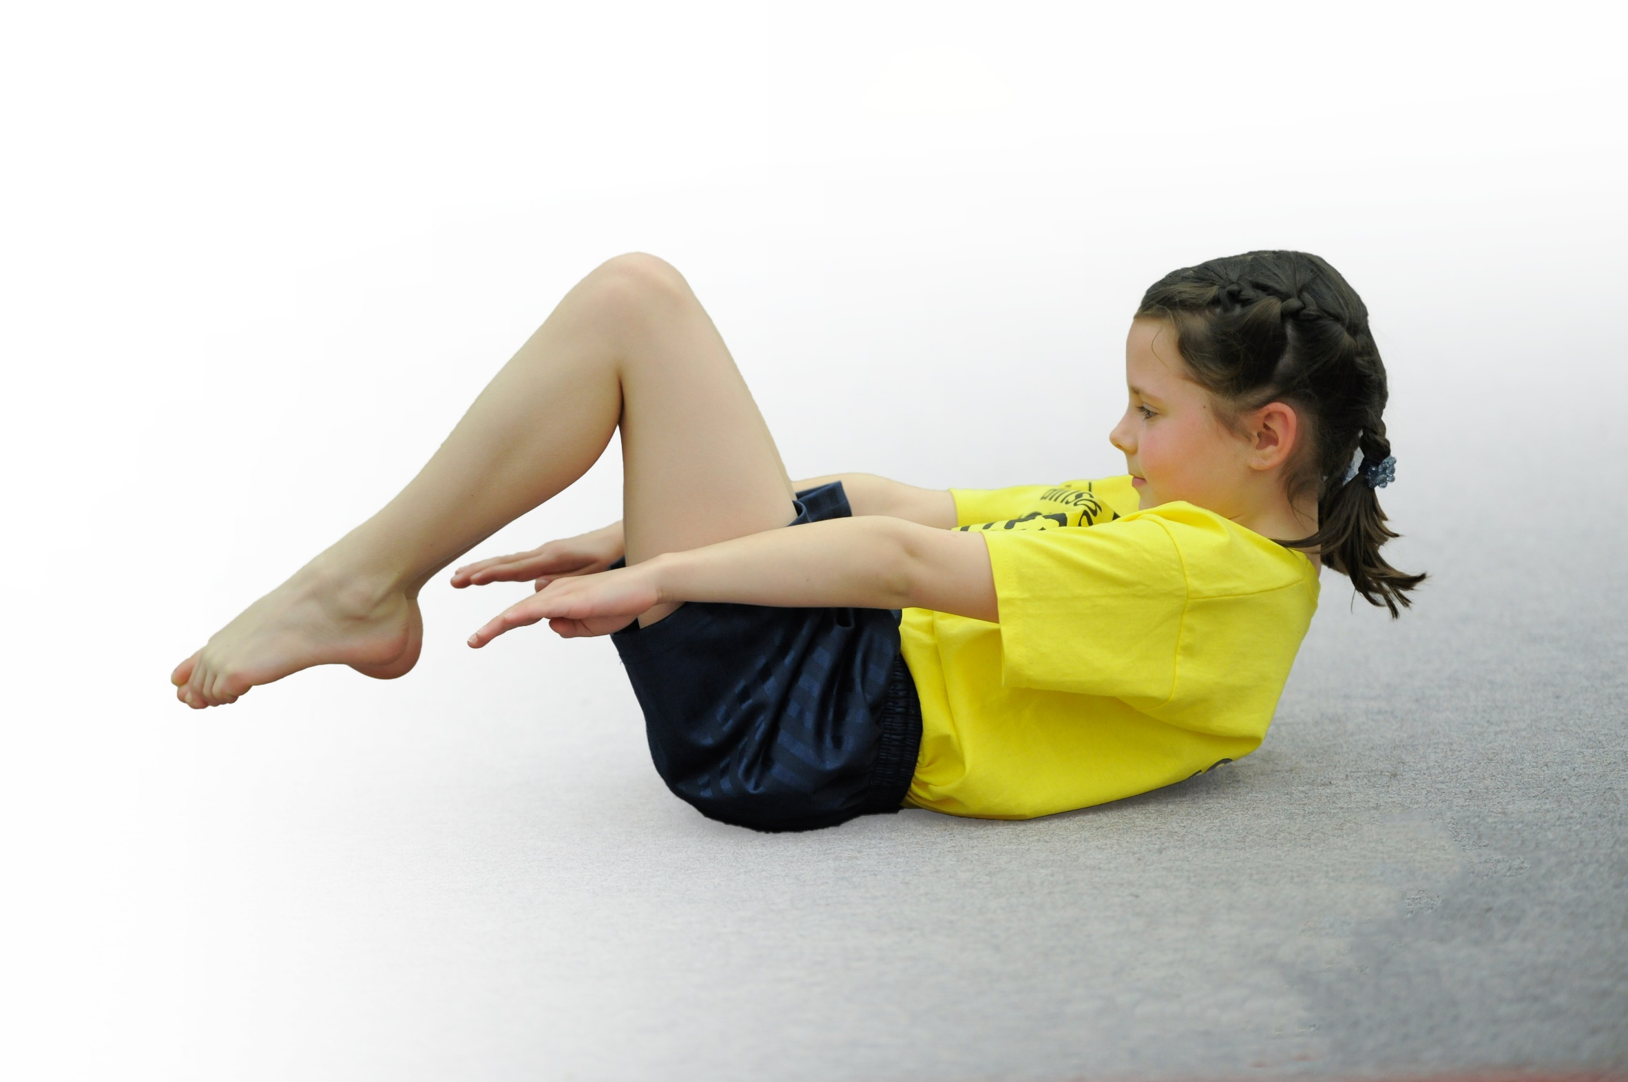
- buildcapacityandcapabilitywithintheschooltoensurethatimprovementsmadenowwillbenefitpupilsjoiningtheschoolinfuture years

Please visit gov.ukfor the revised DfE guidance including the 5 key indicators across which schools should demonstrate an improvement. This document will help you to review your provision and to report your spend. DfE encourages schools to use this template as an effective way of meeting the reporting requirements of the Primary PE and Sport Premium.

We recommend you start by reflecting on the impact of current provision and reviewing the previous spend.
Under the Ofsted Schools Inspection Framework, inspectors will assess how effectively leaders use
the Primary PE and Sport Premium and measure its impact on outcomes for pupils, and how effectively governorshold them to account
for this.

Schools are required to publish detailsof how they spend this funding as well as on the impact it has on pupils’ PE
and sport participation and attainment.
We recommend regularly updating the table and
publishing it on your website as evidence
of your ongoing review into how you are using the money
to secure maximum, sustainable impact. To see an example of how to complete the table please click HERE.
Support for review and reflection - considering the 5 key indicators from DfE, what development needs are a priority for your setting and your students now and why? Use the space below to reflect on previous spend, identify current need and priorities for the future.

Key achievements to date: | Areas for further improvement and baseline evidence of need:
Varied PE curriculum  Inter school competitions and festivals  Opportunity for open water swimming. | Small cohorts of upper ks2 pupils- not a particularly ‘sporty’ year 5 so may need different competition opportunities for upper ks2 (tri-golf)  Ensure daily physical activity is embedded to ensure maximum participation for Year 5 group.

Meeting national curriculum requirements for swimming and water safety | Please complete all of the below*:
What percentage of your current Year 6 cohort swim competently, confidently and proficiently over a distance of at least 25 metres? | 75%
What percentage of your current Year 6 cohort use a range of strokes effectively [for example, front crawl, backstroke and breaststroke]? | 75%
What percentage of your current Year 6 cohort perform safe self-rescue in different water-based situations? | 75%
SchoolscanchoosetousethePrimaryPEandSportPremiumtoprovideadditionalprovisionforswimming but this must be for activity over and above the national curriculum requirements. Have you used it in this way? | No; due to school closure in the summer term.
*Schools may wish to provide this information in April, just before the publication deadline.

Action Plan and Budget Tracking
Capture your intended annual spend against the 5 key indicators. Clarify the success criteria and evidence of impact that you intend to measure to evaluate for students today and for the future.

Academic Year: 2019/20 | Total fund allocated: £16,450 | Date Updated: September 2019
Key indicator 1: The engagement of all pupils in regular physical activity – Chief Medical Officer guidelines recommend that primary school children undertake at least 30 minutes of physical activity a day in school |  |  |  | Percentage of total allocation:
 |  |  |  | %
School focus with clarity on intended impact on pupils: | Actions to achieve: | Funding allocated: | Evidence and impact: | Sustainability and suggested next steps:
Any target groups in the school?  Maintain ‘Tuesday Trot’ running session to 2x weekly so that all pupils engage in 10 minutes of running/brisk walking twice a week.  Playground leaders  Continue with Young Leaders initiative so that upper KS2 remain active and engaged at playtime.  What equipment do we have for pupils to use/engage with at playtimes?  Replace the playground climbing equipment to ensure active playtimes and allow more children to engage in active play.  Ensure that pupils have enough equipment to allow active play at playtimes.  Lunchtime & afterschool club coach?  A different model ? | PB ensure that the routine of 2x weekly Trot continues in the new academic year.  PB plan a timetable for KS2 to lead playtime activities. Monitor resources to ensure equipment is sufficient.  Investigate the options for replacing the equipment.  Lunchtime staff to monitor variety and condition of playtime equipment to ensure that pupils have enough equipment to allow active play.  New after-school club offered in Spring term to engage a wider range of children | £105  £210  £1,298.66 | Trot maintained throughout the autumn and spring term (school closure in the summer) Some pupils maintained their morning runs in lockdown.  All children took part in the ‘Elf Run’ to raise funds for a hospice.  Small playground equipment monitored and replaced where needed.  Large climbing equipment still very popular but not yet replaced.  Two after-school clubs were run in the spring term (Sports Fitness and Acro Gym) Both were popular and well attended by a range of children from KS1 and KS2  Support from/time of PE co-ordinator | Continue into new academic year; include some running challenges (Lakeland Lapland Adventure)  Active playtimes to become a focus for development in 2020/21
Key indicator 2: The profile of PE and sport being raised across the school as a tool for whole school improvement |  |  |  | Percentage of total allocation:
 |  |  |  | %
School focus with clarity on intended impact on pupils: | Actions to achieve: | Funding allocated: | Evidence and impact: | Sustainability and suggested next steps:
How is PE School Sport & Physical activity viewed at the school by pupils, teachers, parents ?  How is PE being embedded into the whole school improvement plan ?  - Improve Emotional Wellbeing  - Improve Behaviour  - Increase Attendance  - Raise Achievement  - Increase Parental Engagement  - Improve Transition and Partnership Working  Outdoor education opportunities for all pupils at some point in the year to develop team co-operation/leadership and resilience skills.  Maintain profile of sports competition and achievement in school;  -sports notice board  -photo and write up in newsletters  -certificates given out in assembly  Start a sports newsletter each term with photos and reports written by the pupils who have participated. | PB to investigate opportunities for whole school outdoor education day in the autumn term and a second activity for each class in the summer term.  Contribution towards the cost of the Outdoor Education Residential for KS2 pupils  PB to update sports notice board/provide photos and write ups for newsletters.  Staff to include sports news/certificates in praise assemblies.  PB to initiate pupils to contribute to a termly sports newsletter. | £920  £1060  £1,263.88 | All pupils took part in a whole school outdoor education day which included sailing, kayaking and canoeing challenges. Real enjoyment and participation by all pupils, positive introduction to outdoor education for the Reception children. Co-operation and team building skills in evidence all day.  Autumn Term; outdoor education residential for all KS2 children.  Summer term activities did not take place due to school closure.  PE notice board updated when competition taken place. Updates on Facebook after events.  Support from/time of PE co-ordinator | Further whole school/ class outdoor education activities to take place in new academic year.

Key indicator 3: Increased confidence, knowledge and skills of all staff in teaching PE and sport |  |  |  | Percentage of total allocation:
 |  |  |  | %
School focus with clarity on intended  impact on pupils: | Actions to achieve: | Funding  allocated: | Evidence and impact: | Sustainability and suggested  next steps:
Consider the 3 contexts :  - Curriculum PE  - Physical Activity  - School Sport  What are the staff needs, wants & priorities ?  Confidence, competence or other ?  Ensure staff have enough support/training/resources to deliver a broad and balanced PE curriculum.  Further dance/gymnastics CPD for RY, working alongside dance/gymnastics teacher.  Net/wall games CPD for SK/PB to develop skills and knowledge for future lessons/after school clubs. | PB to request that CS to include staff audit in a staff meeting in the autumn term. If not possible then PB can email all staff with an audit.  Coaching staff already booked for CPD/class work in autumn/spring term. | £1,500  £1,263.88 | Dance/gymnastics/net games CPD took place for staff in autumn and spring term.  Dance/gym training used in subsequent KS1 lessons. Net/wall games training used in an after school club.  PE resources monitored and replaced each term where needed.  PE co-ordinator completed online training during school closure in relation to PE planning and delivery of a game based approach to PE lessons. | Continue with CPD in dance/gym.  Support curriculum delivery with a PE scheme which focuses on game based delivery of PE activities.
Key indicator 4: Broader experience of a range of sports and activities offered to all pupils |  |  |  | Percentage of total allocation:
 |  |  |  | %
School focus with clarity on intended  impact on pupils: | Actions to achieve: | Funding  allocated: | Evidence and impact: | Sustainability and suggested  next steps:
- Development of Physical Literacy  - Age and stage appropriate development  - Holistic child development  - Opportunity PE & SS provides that other lessons/subjects can not ?  - A platform to go onto sport specific participation  - PE not Multi-sport agenda  - Making more use of OAA rather than traditional sports ?  Continue to offer a range of sports/PE activities within curriculum time and after-school clubs to engage all pupils and develop a range of skills.  Swimming lessons offered to all pupils to develop water confidence and swimming skills.  Ensure all pupils in Yr5,6 can swim 25m  Whole school cycling day in Grizedale Forest to develop/challenge cycling skills.  KS1 cycling skills development day.  (practice riding/ develop maneuvering skills/ off road cycling for yr2) | PB to plan a varied PE curriculum map which includes support of specialists where necessary.  Take up workshop opportunities for delivery/experience of different types of physical activity.  Use after-school club coaches where available to supplement the clubs that staff can offer.  PB to arrange swimming lessons for all pupils in summer term.  PB to arrange open water swimming sessions for Yr5,6 in summer term.  Plan a date in Spring Term for day of cycling/ picnic lunch/followed by team building activities in forest.  Plan a date in autumn/spring/summer term for KS1 to bring bikes and take part in cycling skills development activities. | £764.00  £300 | PE curriculum in autumn and spring term was varied; supported by a mixture of staff and specialist teacher delivery.  Seven different after school clubs and one lunchtime club were offered over the course of the autumn and spring term (Multi-sports, tennis, running, gymnastics, dance, sports fitness, cricket)  There was a Bollywood dance workshop for all pupils in the autumn term and a music/dance workshop in the spring term, which supplemented the dance curriculum with an experience of different styles of dance.  Swimming lessons did not take place due to school closure. | PE coordinator to review and re-write the Long Term PE plan to highlight the holistic child developments which PE & SS can offer to children.
Key indicator 5: Increased participation in competitive sport |  |  |  | Percentage of total allocation:
 |  |  |  | %
School focus with clarity on intended  impact on pupils: | Actions to achieve: | Funding  allocated: | Evidence and impact: | Sustainability and suggested  next steps:
- Afterschool & lunchtime clubs linked to competitions  - Access for all V access for G&T pupils  - What does success and winning mean to us at competition ?  Maintain current level of sports competitions and introduce additional competitions to ensure that all pupils attend at least 2 competitions this year.  Maintain/increase KS1 participation in inter school festivals to ensure that all pupils attend at least 2 festivals. | Arrange to attend as many L2 School Games Competitions as possible.  Attend any local schools competitions that are arranged at The Lakes School.  Attend as many friendly festivals as possible | £520.00  £1,894.77 | KS2 pupils participated in a L2 netball, gymnastics and three cross country competitions in the autumn and spring term. Year 2 participated in a gymnastics competition and a cricket festival. All other events were cancelled due to school closure.  Support of/time of PE coordinator. | Continue with inter school competition where possible in the next academic year. Include participation in virtual school competition where available.  Include some element of competition in KS2 PE curriculum. Include point scoring activities and scoring personal challenges in KS1 curriculum.

