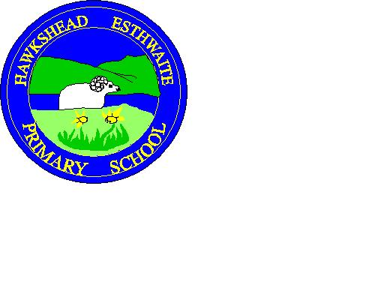
Hawkshead Esthwaite Primary School
Newsletter
21st December 2018
Events for 2019
Monday – KS1 Multi sports. Finishes at 4pm.
Tuesday – Trot am and running club at lunch time. Trainers Required! Secret agents.
Wednesday – Music Lessons. Badminton club Y3-Y6
Thursday – Wake and shake am. Art club Y3-Y6. (12 Places)
Friday – Sharing assembly 9.15.
Chess/ Cricket.

Wednesday 9th January.

Cross country for some Y3,4,5 and 6 children.

Leaving school at 11.30 and back around 5.30. Please see previous letter for more information. And please return consent forms.

Merry Christmas and a Happy New Year from all the staff at Hawkshead Primary School.

See you all on Tuesday 8th January 2019.

PTA – New members welcome!

There is a slight change to term dates in February. School will be closed for teacher training on Monday 25th February. This is the Monday after half term.

