

Schools must use the funding to make additional and sustainable improvements to the quality of PE and sport they offer. This means that you should use the Primary PE and Sport Premium to:

- developoraddtothePEandsportactivitiesthatyourschoolalready offers
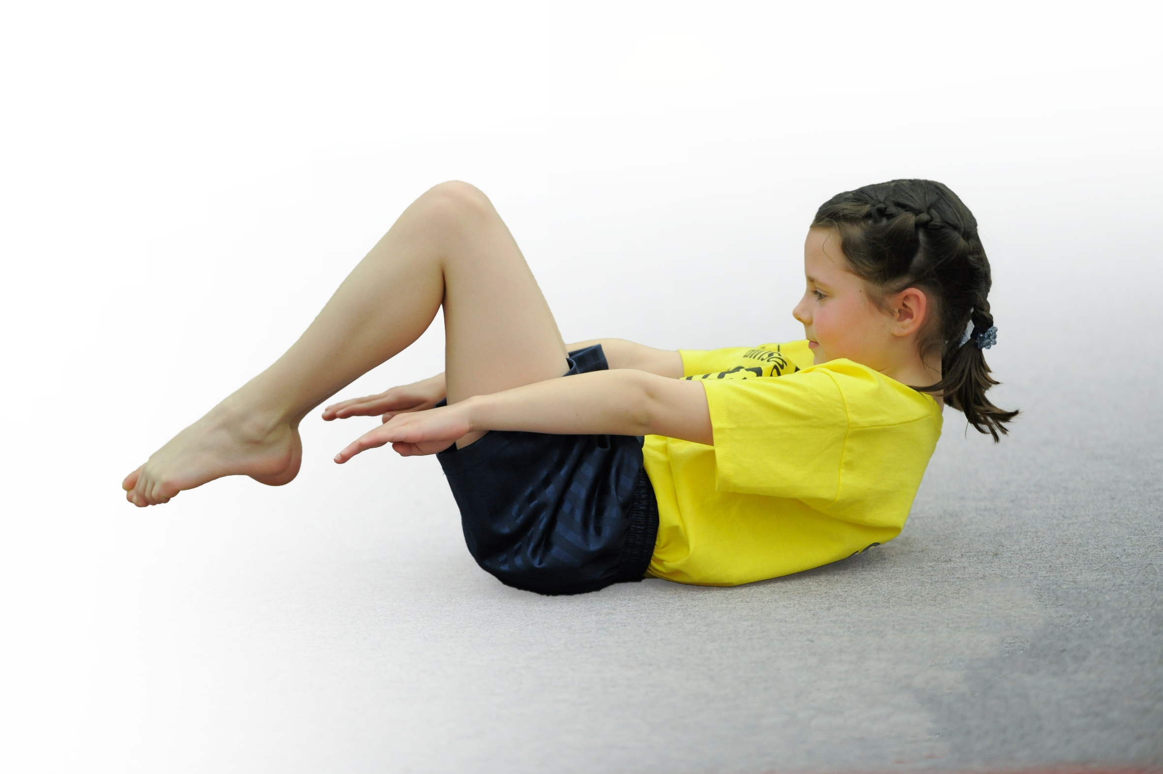
- buildcapacityandcapabilitywithintheschooltoensurethatimprovementsmadenowwillbenefitpupilsjoiningtheschoolinfuture years

Please visit gov.ukfor the revised DfE guidance including the 5 key indicators across which schools should demonstrate an improvement. This document will help you to review your provision and to report your spend. DfE encourages schools to use this template as an effective way of meeting the reporting requirements of the Primary PE and Sport Premium.

We recommend you start by reflecting on the impact of current provision and reviewing the previous spend.
Under the Ofsted Schools Inspection Framework, inspectors will assess how effectively leaders use
the Primary PE and Sport Premium and measure its impact on outcomes for pupils, and how effectively governorshold them to account
for this.

Schools are required to publish detailsof how they spend this funding as well as on the impact it has on pupils’ PE
and sport participation and attainment.
We recommend regularly updating the table and
publishing it on your website as evidence
of your ongoing review into how you are using the money
to secure maximum, sustainable impact. To see an example of how to complete the table please click HERE.
Support for review and reflection - considering the 5 key indicators from DfE, what development needs are a priority for your setting and your students now and why? Use the space below to reflect on previous spend, identify current need and priorities for the future.

Key achievements to date: | Areas for further improvement and baseline evidence of need:
April 2018- KS2 pupils have competed in 6 inter-school competitions.  - KS1 pupils competed in Key Steps gym and a friendly cricket festival.  - All KS2 pupils continue to receive 2 hours of curriculum PE.  - KS2 have a varied PE curriculum.  - Regular weekly runs and Wake and Shake sessions.  - 2 after-school sports clubs run throughout the year. | Inclusion of pupils who do not regularly attend a club.  Begin a ‘Change for Life Club’  Offer a varying range of after-school clubs.

Meeting national curriculum requirements for swimming and water safety | Please complete all of the below*:
What percentage of your current Year 6 cohort swim competently, confidently and proficiently over a distance of at least 25 metres? | 100%
What percentage of your current Year 6 cohort use a range of strokes effectively [for example, front crawl, backstroke and breaststroke]? | 100%
What percentage of your current Year 6 cohort perform safe self-rescue in different water-based situations? | 100% by the end of July 2018
SchoolscanchoosetousethePrimaryPEandSportPremiumtoprovideadditionalprovisionforswimming but this must be for activity over and above the national curriculum requirements. Have you used it in this way? | Yes- Open water swimming
*Schools may wish to provide this information in April, just before the publication deadline.

Action Plan and Budget Tracking
Capture your intended annual spend against the 5 key indicators. Clarify the success criteria and evidence of impact that you intend to measure to evaluate for students today and for the future.

Academic Year: 2017/18 | Total fund allocated: £16,490 | Date Updated: January 2018
Key indicator 1: The engagement of all pupils in regular physical activity – Chief Medical Officer guidelines recommend that primary school children undertake at least 30 minutes of physical activity a day in school |  |  |  | Percentage of total allocation:
 |  |  |  | %
School focus with clarity on intended impact on pupils: | Actions to achieve: | Funding allocated: | Evidence and impact: | Sustainability and suggested next steps:
Introduce ‘Wake and Shake’ session each week so that all pupils will engage in an additional 15mins activity.  Introduce a ‘Change for Life Club’ to target pupils who do not normally attend a club.  Re-start football club- a well attended club in the past (new coach required)  Resource update and replacement, to ensure that there is enough equipment for full participation by all pupils or the right equipment for new sports.  Replace the playground climbing equipment to ensure active playtimes and allow more children to engage in active play. | Re-new subscription to Cyber coach (Wake and Shake resource)  Identify and train a staff member (TA or after school care staff) to run a club.  Source a new football coach.  PE co-ordinator to check equipment on a termly basis.  Investigate the options for replacing the equipment. | £100.  £150  £300  £500 | Newsletter  All pupils take part in a Wake and Shake session each week- movement confidence is growing in EY pupils. Older pupils are taking leadership roles.  Club register  Club register
Key indicator 2: The profile of PE and sport being raised across the school as a tool for whole school improvement |  |  |  | Percentage of total allocation:
 |  |  |  | %
School focus with clarity on intended impact on pupils: | Actions to achieve: | Funding allocated: | Evidence and impact: | Sustainability and suggested next steps:
Further develop participation in inter-school competition.  Increase KS1 participation in inter-school festivals.  Competition participation is mentioned in Praise Assembly/ school newsletter and on website.  PE noticeboard in school (input from children included; competition reports etc)  Links made between sport and School Development Plan as part of SMSC values.  Development of Young Leaders (Wake and Shake leaders/ lead small groups in clubs/ Sports Day Leaders. | Staff to take pupils to as many sports competitions as possible.  PE coordinator to liaise with other local schools to develop a friendly festival.  PE coordinator to write reports for newsletter/website and include a photo.  Certificates given out in assembly.  PE coordinator to update with photos. Children asked to contribute.  Include national and international sporting events in assembly themes- linked to values of competitive sport.  Link SMSC themes to PSE aspects of sport and healthy lifestyles.  Liaise with School Games Co-ordinator to access Young Leader Training. | £2,000  £300  £100 | PE records  To date (April 18) the majority of KS2 pupils have competed in at least 1 inter-school competition.  The school has entered 6 KS2 competitions so far.  One KS2 netball team/ one gym team competed in a Level 2 competition.  All KS1 pupils took part in a inter school cricket festival and 12 children (out of 18) took part in The Level 1 Key Steps Competition.  Newsletter/website  April 2018- School PE noticeboard is active in the entrance area and competition photos will be posted on new school website.  Common wealth games assembly.  Links between SMSC and sporting values included in school development plan.

Key indicator 3: Increased confidence, knowledge and skills of all staff in teaching PE and sport |  |  |  | Percentage of total allocation:
 |  |  |  | %
School focus with clarity on intended  impact on pupils: | Actions to achieve: | Funding  allocated: | Evidence and impact: | Sustainability and suggested  next steps:
KS1 gymnastics CPD for CS- develop gymnastic delivery skills for future lessons.  Cricket CPD for NH- develop new ideas for cricket club delivery.  Use of PE School Sport Tracker- evidence progress of pupils and identify gaps in skills.  Use of tablets to record and assess (teacher and peer) pupils achievements and progress in PE  Train TA to deliver ‘Change for Life’ club.  Develop skills of RY (NQT) in EYFS PE delivery. | Observe the lessons of GS (gym coach)  Join cricket sessions of SL (cricket coach)  PB attend training for and purchase PE & Sports Tracker. Introduce to staff.  Source a TA to deliver and arrange training.  Source appropriate training courses for RY. | £180  £350.  £2000 (4 tablets) | PE Long term plan  NH observed weekly cricket lessons over a half term, resulting in new ideas and activities for cricket club.  CPD records
Key indicator 4: Broader experience of a range of sports and activities offered to all pupils |  |  |  | Percentage of total allocation:
 |  |  |  | %
School focus with clarity on intended  impact on pupils: | Actions to achieve: | Funding  allocated: | Evidence and impact: | Sustainability and suggested  next steps:
Additional achievements:  Continue to offer a range of sports/skills within curriculum time and after-school clubs.  Target pupils who do not take up opportunities to attend after-school clubs- offering new clubs (cycling/ hockey/ golf)  Swimming lessons offered to Yr1,2 pupils. | Ensure a varied long term plan for curriculum PE.  PE co-ordinator to contact and organize sports coaches.  Approach after-school care club staff with the suggestion that one of them runs a ‘Change for Life Club.’  PE co-ordinator audit club’s register.  Pupils survey on suggestions for clubs.  Pursue connections with Hawkshead Recreation Ground Committee to develop sports facilities on The Rec Ground.  Source a pool, instructor & transport for KS1 lessons. | £5000.  £500 | PE Long Term Plan  Clubs register.  KS2 have engaged in 6 different sports during curriculum PE over the first two terms.  Netball/Key Steps gym competition was entered following curriculum PE sessions on these subjects- teams in both competitions qualified for the next round.  Pupil survey was conducted around pupil’s interest in curriculum PE/after-school clubs and playtimes. Responses have been included in this plan.  School Council have also represented interests around PE/School Sport, resulting in a new lunchtime running club.
Key indicator 5: Increased participation in competitive sport |  |  |  | Percentage of total allocation:
 |  |  |  | %
School focus with clarity on intended  impact on pupils: | Actions to achieve: | Funding  allocated: | Evidence and impact: | Sustainability and suggested  next steps:
Maintain current level of sports competitions and introduce additional competitions.  Increase KS1 participation in inter school festivals. | Arrange to attend as many L2 School Games Competitions as possible.  Attend any local schools competitions as possible that are arranged at The Lakes School.  Contact another local school to develop a KS1 multi skills festival. |  | PE co-ordinator records.  SGO correspondence.  To date (April 18) the majority of KS2 pupils have competed in at least 1 inter-school competition.  The school has entered 6 KS2 competitions so far.  One KS2 netball team/ one gym team competed in a Level 2 competition.  KS1 have participated in a cricket festival which was new to the competition calendar this time.  12 out of 18 KS1 pupils, took part in The Key Steps Competition.

